|  |  |  |  |  |  |  |  |  |  |  |  |  |
| --- | --- | --- | --- | --- | --- | --- | --- | --- | --- | --- | --- | --- |
| |  |  | | --- | --- | | **СОГЛАСОВАНО:** |  | | **Генеральный директор**  **ООО «ФРЭКОМ»** |  | | ______________ **В.В. Минасян** |  | | «____» ______________ **2024 г.** |  | | **М.П.** |  | |  |  | |

**Реализация комплексной программы мониторинга экологического состояния Обской губы в зоне влияния проекта «Ямал СПГ» в 2023-2024 годах**

**ОТЧЕТ ПО ЭТАПУ 4**

**«Сбор автоматических донных станций»**

*Итоговый отчет по данным 2023-2024 гг.*

Книга 2. Текстовые приложения. Часть 3.

***ЗАКАЗЧИК: ОАО «Ямал СПГ»***

г. Москва, 2024

# СОСТАВ ОТЧЕТНОЙ ДОКУМЕНТАЦИИ

|  |  |  |  |
| --- | --- | --- | --- |
| **№ Книги** | **Наименование** | | **Примечание** |
| 1 | Отчет по этапу 4 «Сбор автоматических донных станций»  Итоговый отчет по данным 2023-2024 гг.  Книга 1. Текст отчета | |  |
| 2 | Отчет по этапу 4 «Сбор автоматических донных станций»  Итоговый отчет по данным 2023-2024 гг.  Книга 2. Текстовые приложения | Часть 1. |  |
| Часть 2. |
| Часть 3. |
| 3 | Отчет по этапу 4 «Сбор автоматических донных станций»  Итоговый отчет по данным 2023-2024 гг.  Книга 3. Графические приложения | |  |

# СПИСОК ИСПОЛНИТЕЛЕЙ

| **ФИО** | **Организация** | **Роль в проекте** |
| --- | --- | --- |
| Шахин Дмитрий Александрович | ООО «ФРЭКОМ» | Начальник отдела ИЭИ и ОССОС |
| Низамутдинова Индира Маратовна | ООО «ФРЭКОМ» | Заместитель начальника отдела ИЭИ и ОССОС |
| Амаров Георгий Леонидович | ООО «ФРЭКОМ» | Главный специалист |
| Валуева Анна Сергеевна | ООО «ФРЭКОМ» | Специалист по ГИС |
| Ликутова Ольга Андреевна | ООО «ФРЭКОМ» | Главный специалист |
| Рыбкина Галина Ивановна | ООО «ФРЭКОМ» | Технический редактор |
| Сохранных Виталий Александрович | ООО «ФРЭКОМ» | Специалист по ГИС |
| Шабалин Николай Вячеславович | ООО «ЦМИ МГУ» | Генеральный директор |
| Дорошенко Сергей Викторович | ООО «ЦМИ МГУ» | Исполнительный директор |
| Ковригина Екатерина Евгеньевна | ООО «ЦМИ МГУ» | Управление ПИР: начальник отдела экологии |
| Адищева Ольга Сергеевна | ООО «ЦМИ МГУ» | Управление ПИР: ведущий специалист отдела экологии |
| Владимирова Анна Александровна | ООО «ЦМИ МГУ» | Управление ПИР: специалист отдела экологии |
| Скавинская Надежда Юрьевна | ООО «ЦМИ МГУ» | Управление ПИР: специалист отдела экологии |
| Разгон Ольга Владимировна | ООО «ЦМИ МГУ» | Управление ПИР: главный гидрохимик отдела экологии |
| Наконечная Алина Сергеевна | ООО «ЦМИ МГУ» | Управление ПИР: инженер-эколог отдела экологии |
| Павлова Алевтина Александровна | ООО «ЦМИ МГУ» | Управление ПИР: инженер-эколог отдела экологии |
| Евдокимов Александр Александрович | ООО «ЦМИ МГУ» | Управление ПИР: начальник отдела гидрометеорологии |
| Чурбаев Артём Раилевич | ООО «ЦМИ МГУ» | Управление ПИР: гидрометеоролог отдела гидрометеорологии |
| Ермилова Юлия Владимировна | ООО «ЦМИ МГУ» | Управление ГИТ: начальник отдела картографии |
| Дребезова Александра Федоровна | ООО «ЦМИ МГУ» | Управление ГИТ: ведущий специалист отдела картографии |
| Кокорин Александр Игоревич | ООО «ЦМИ МГУ» | Управление НИР: заместитель руководителя лаборатории гидробиологии |
| Швед Вера Андреевна | ООО «ЦМИ МГУ» | Управление ПИР: инженер-эколог отдела экологии |

# Содержание

СОСТАВ ОТЧЕТНОЙ ДОКУМЕНТАЦИИ 2

СПИСОК ИСПОЛНИТЕЛЕЙ 3

Содержание 4

Приложение У. Копии протоколов количественного биологического анализа 5

Приложение У.2. Копии протоколов КБА проб хлорофилла «а» 5

Приложение У.3. Копии протоколов КБА проб первичной продукции 12

Приложение У.4. Копии протоколов КБА проб зоопланктона 15

Приложение У.5. Копии протоколов КБА проб ихтиопланктона 123

Приложение У.6. Копии протоколов КБА проб макрозообентоса 231

Приложение Ф Характеристика гидрохимических условий и загрязненности воды 341

Приложение Ф.1. Гидрохимические показатели состояния воды акватории Обской губы в августе 2023 г. 341

Приложение Ф.2. Содержание биогенных элементов в воде акватории Обской губы в августе 2023 г. 347

Приложение Ф.3. Содержание тяжелых металлов и мышьяка в воде акватории Обской губы в августе 2023 г. 353

Приложение Ф.4. Содержание органических загрязняющих веществ в воде акватории Обской губы в августе 2023 г. 359

Приложение Ц. Гидробиологическая характеристика акватории 365

Приложение Ц.1. Видовой состав фитопланктона Обской губы в августе 2023 г. (станции 1-50). 365

Приложение Ц.2. Видовой состав фитопланктона Обской губы в августе 2023 г (станции 51-100). 380

Приложение Ц.3. Видовой состав фитопланктона Обской губы в августе 2023 г (станции продольного профиля). 394

# Приложение У. Копии протоколов количественного биологического анализа

## Приложение У.2. Копии протоколов КБА проб хлорофилла «а»

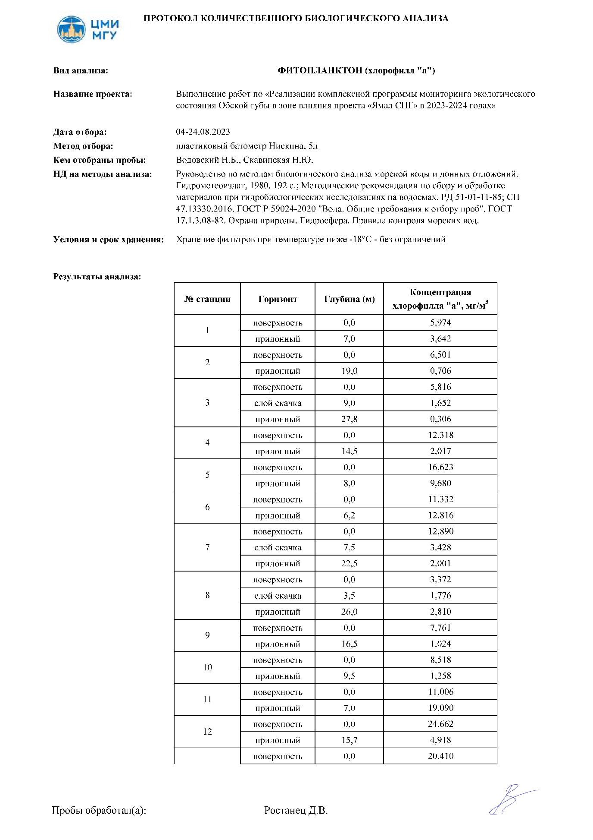

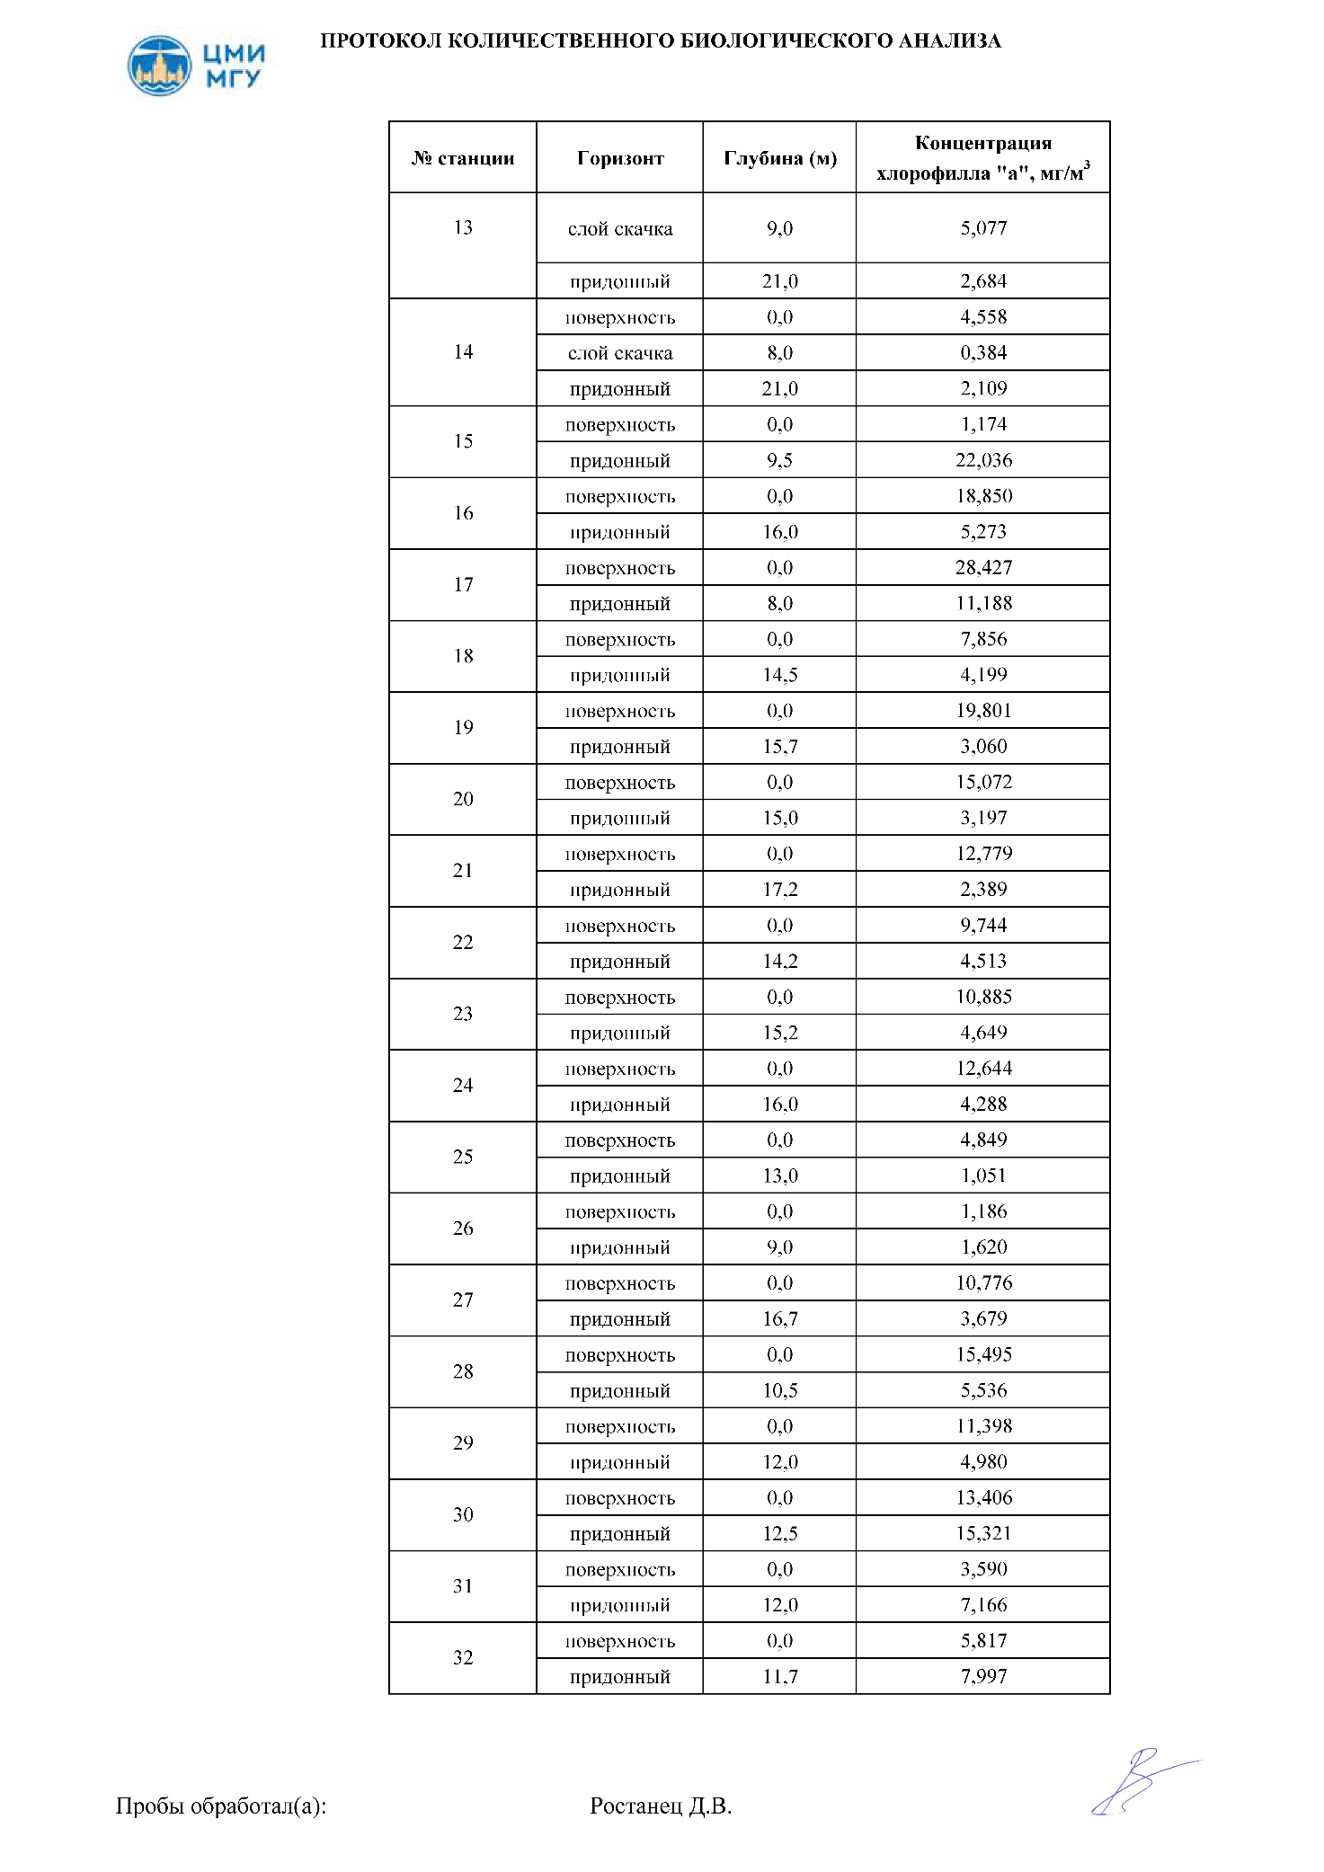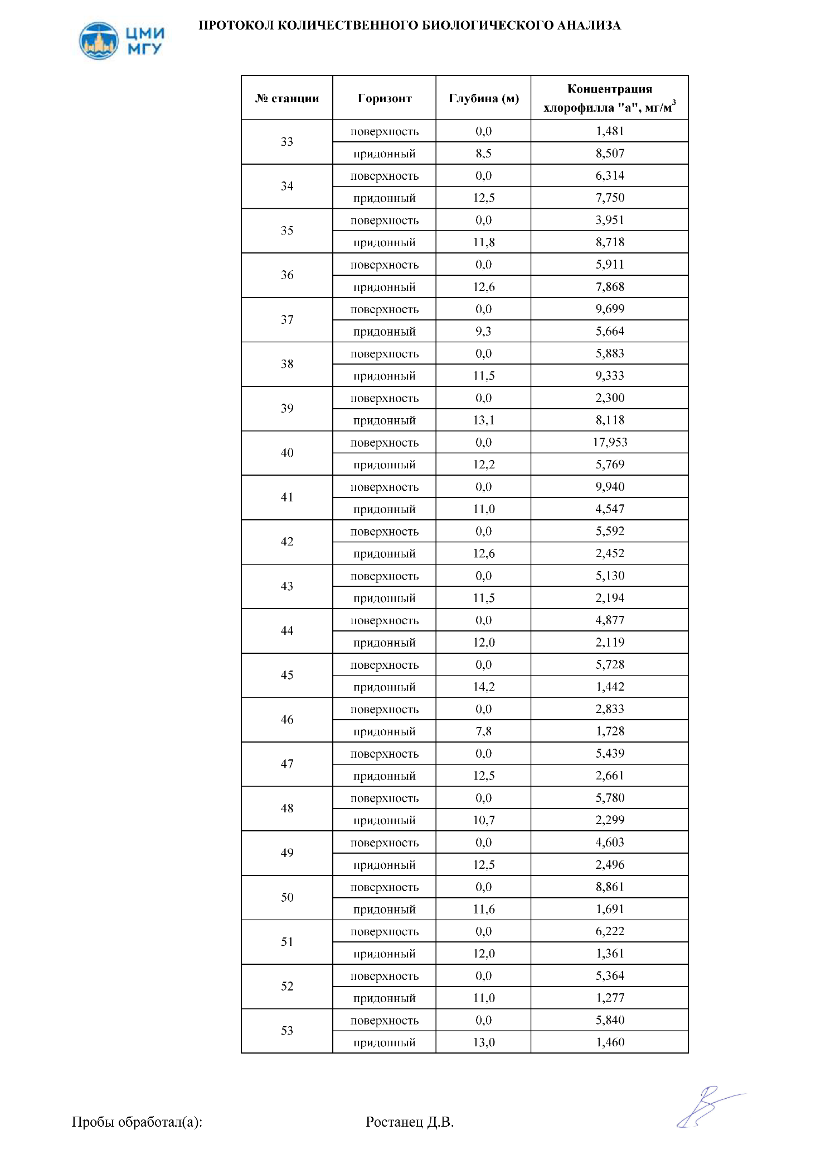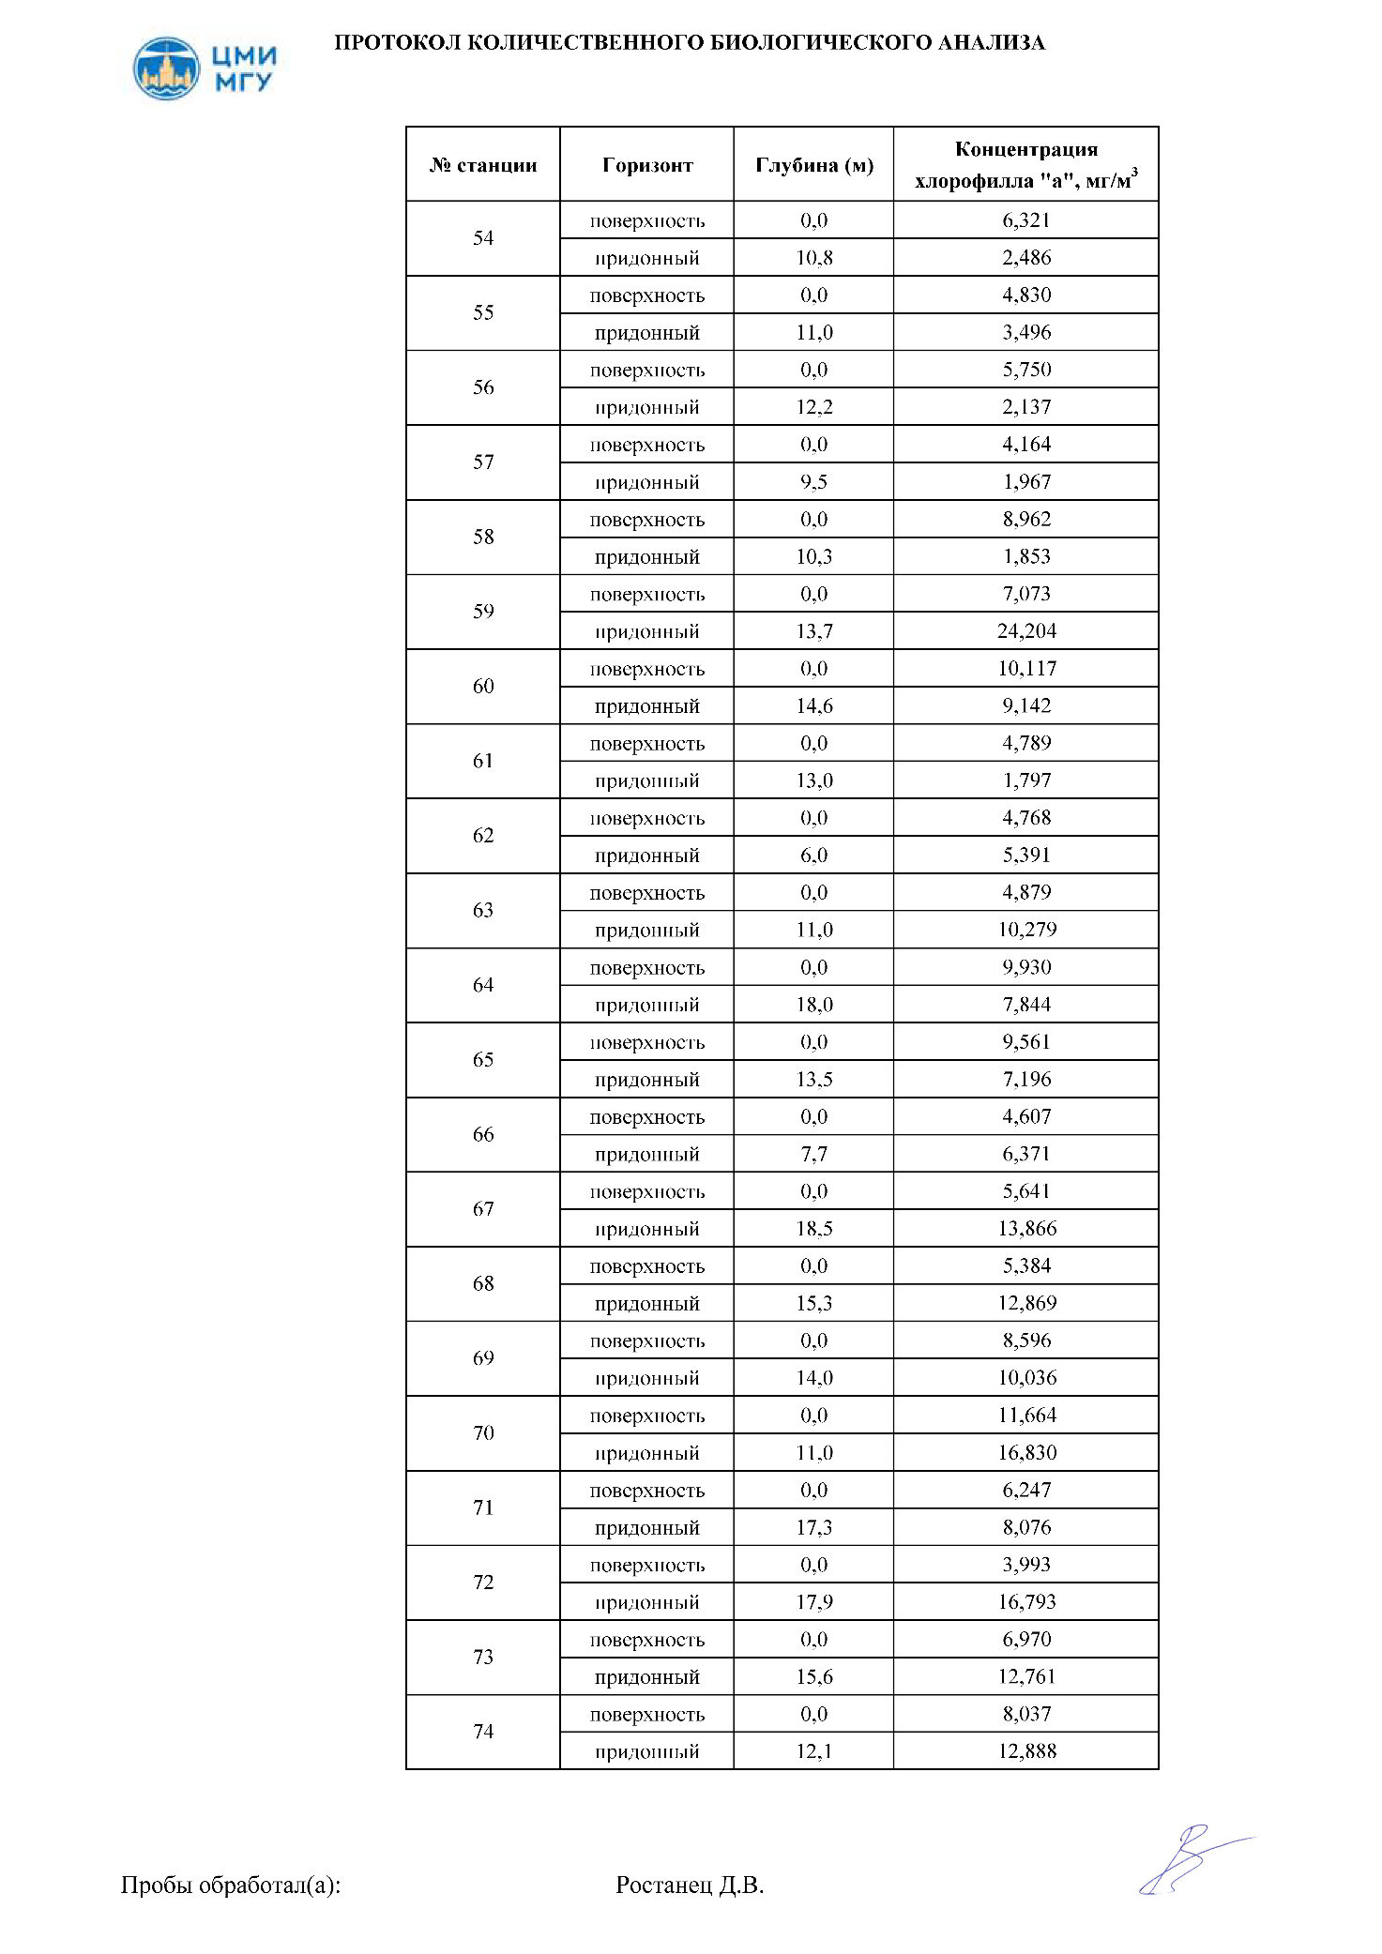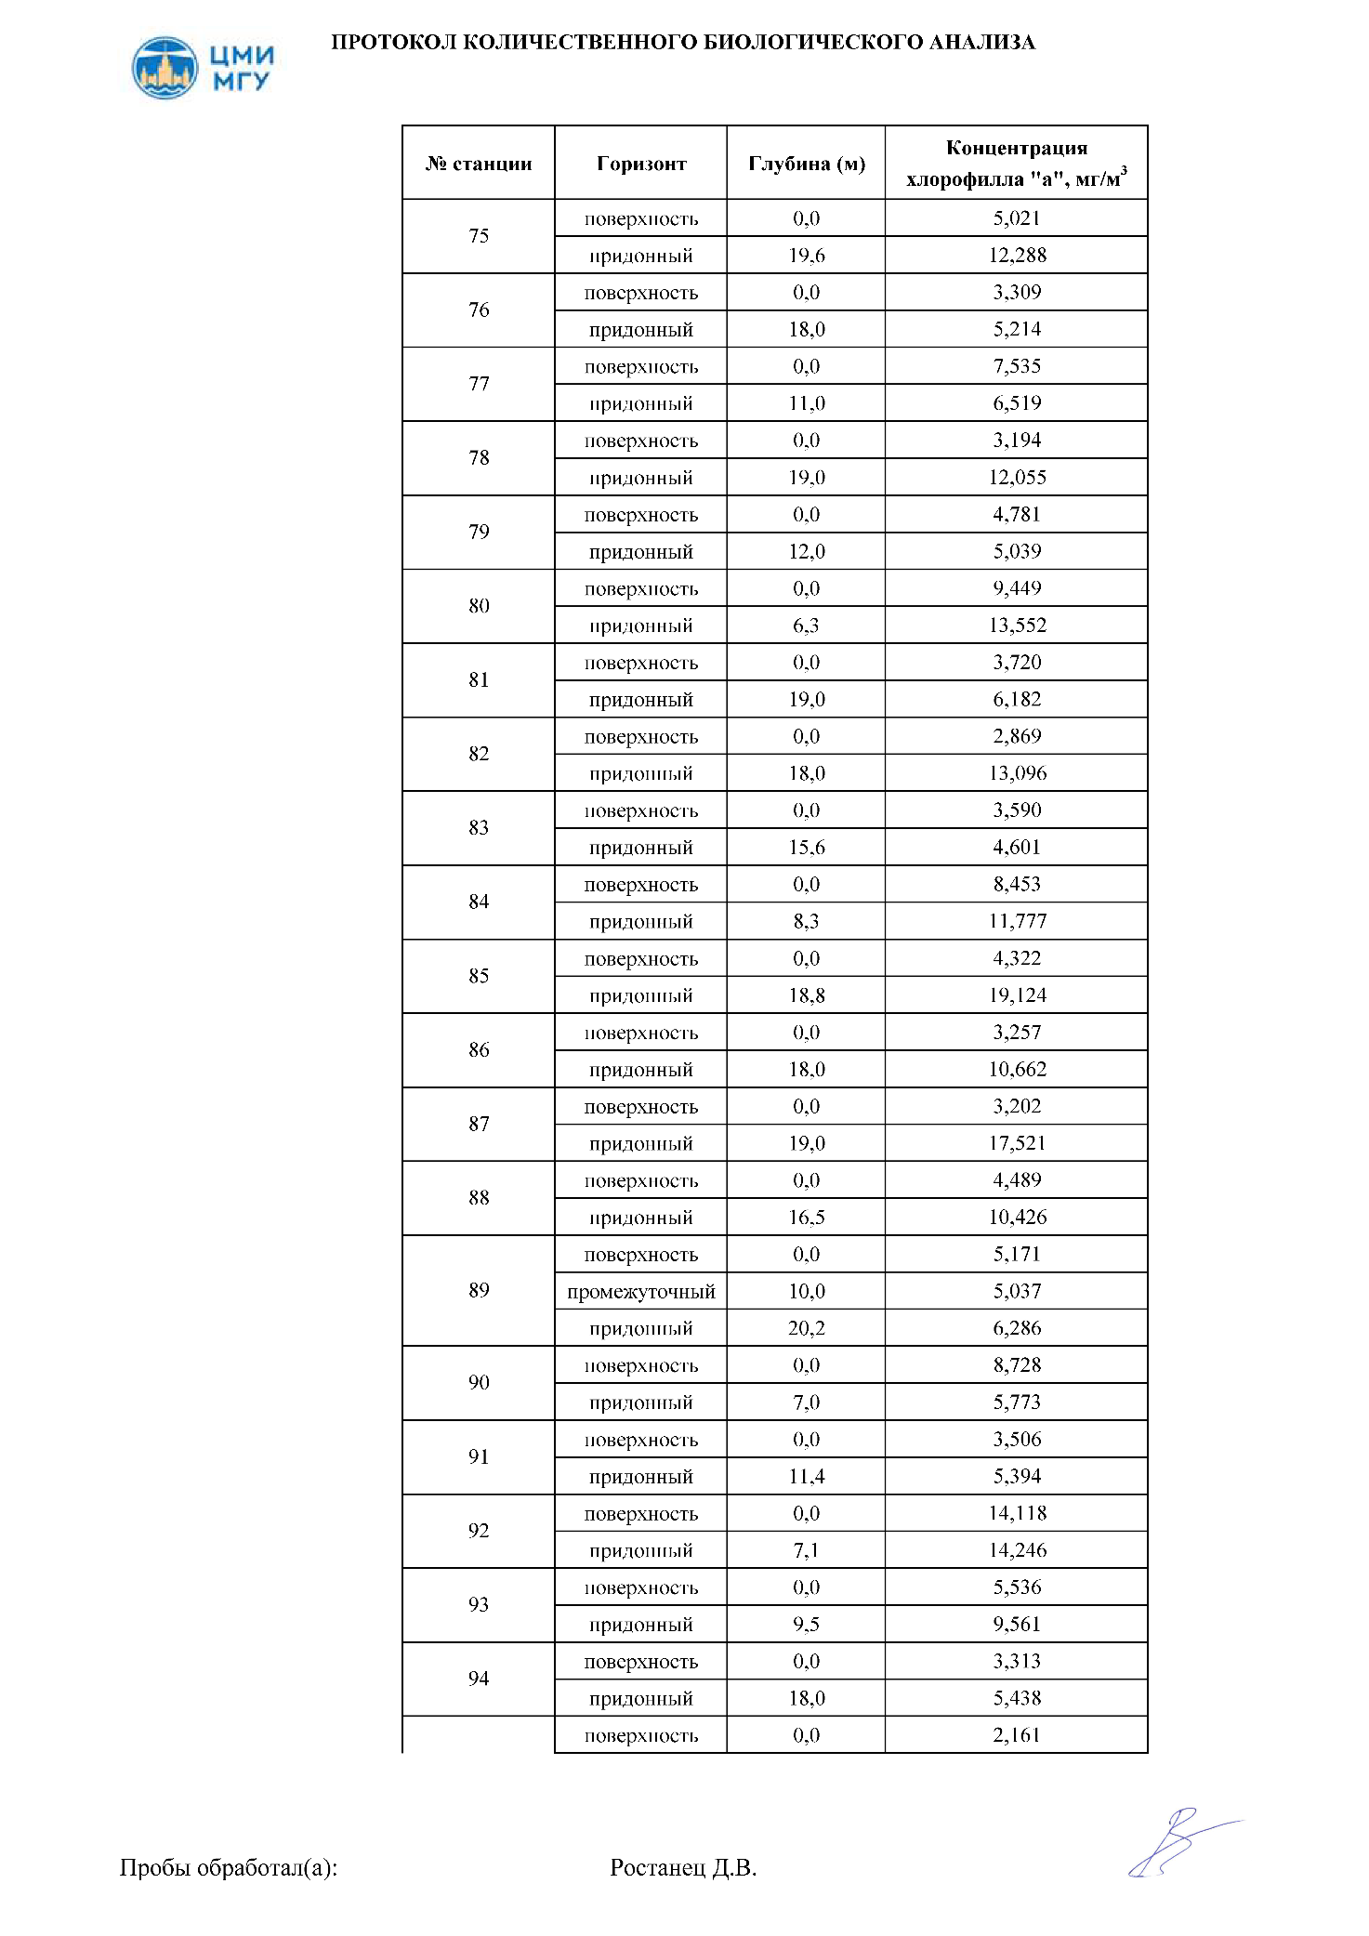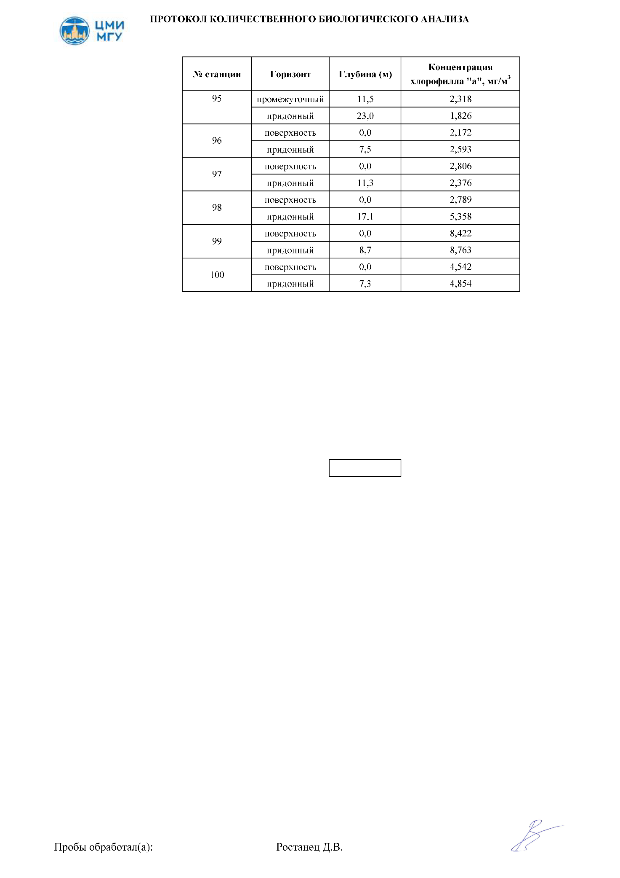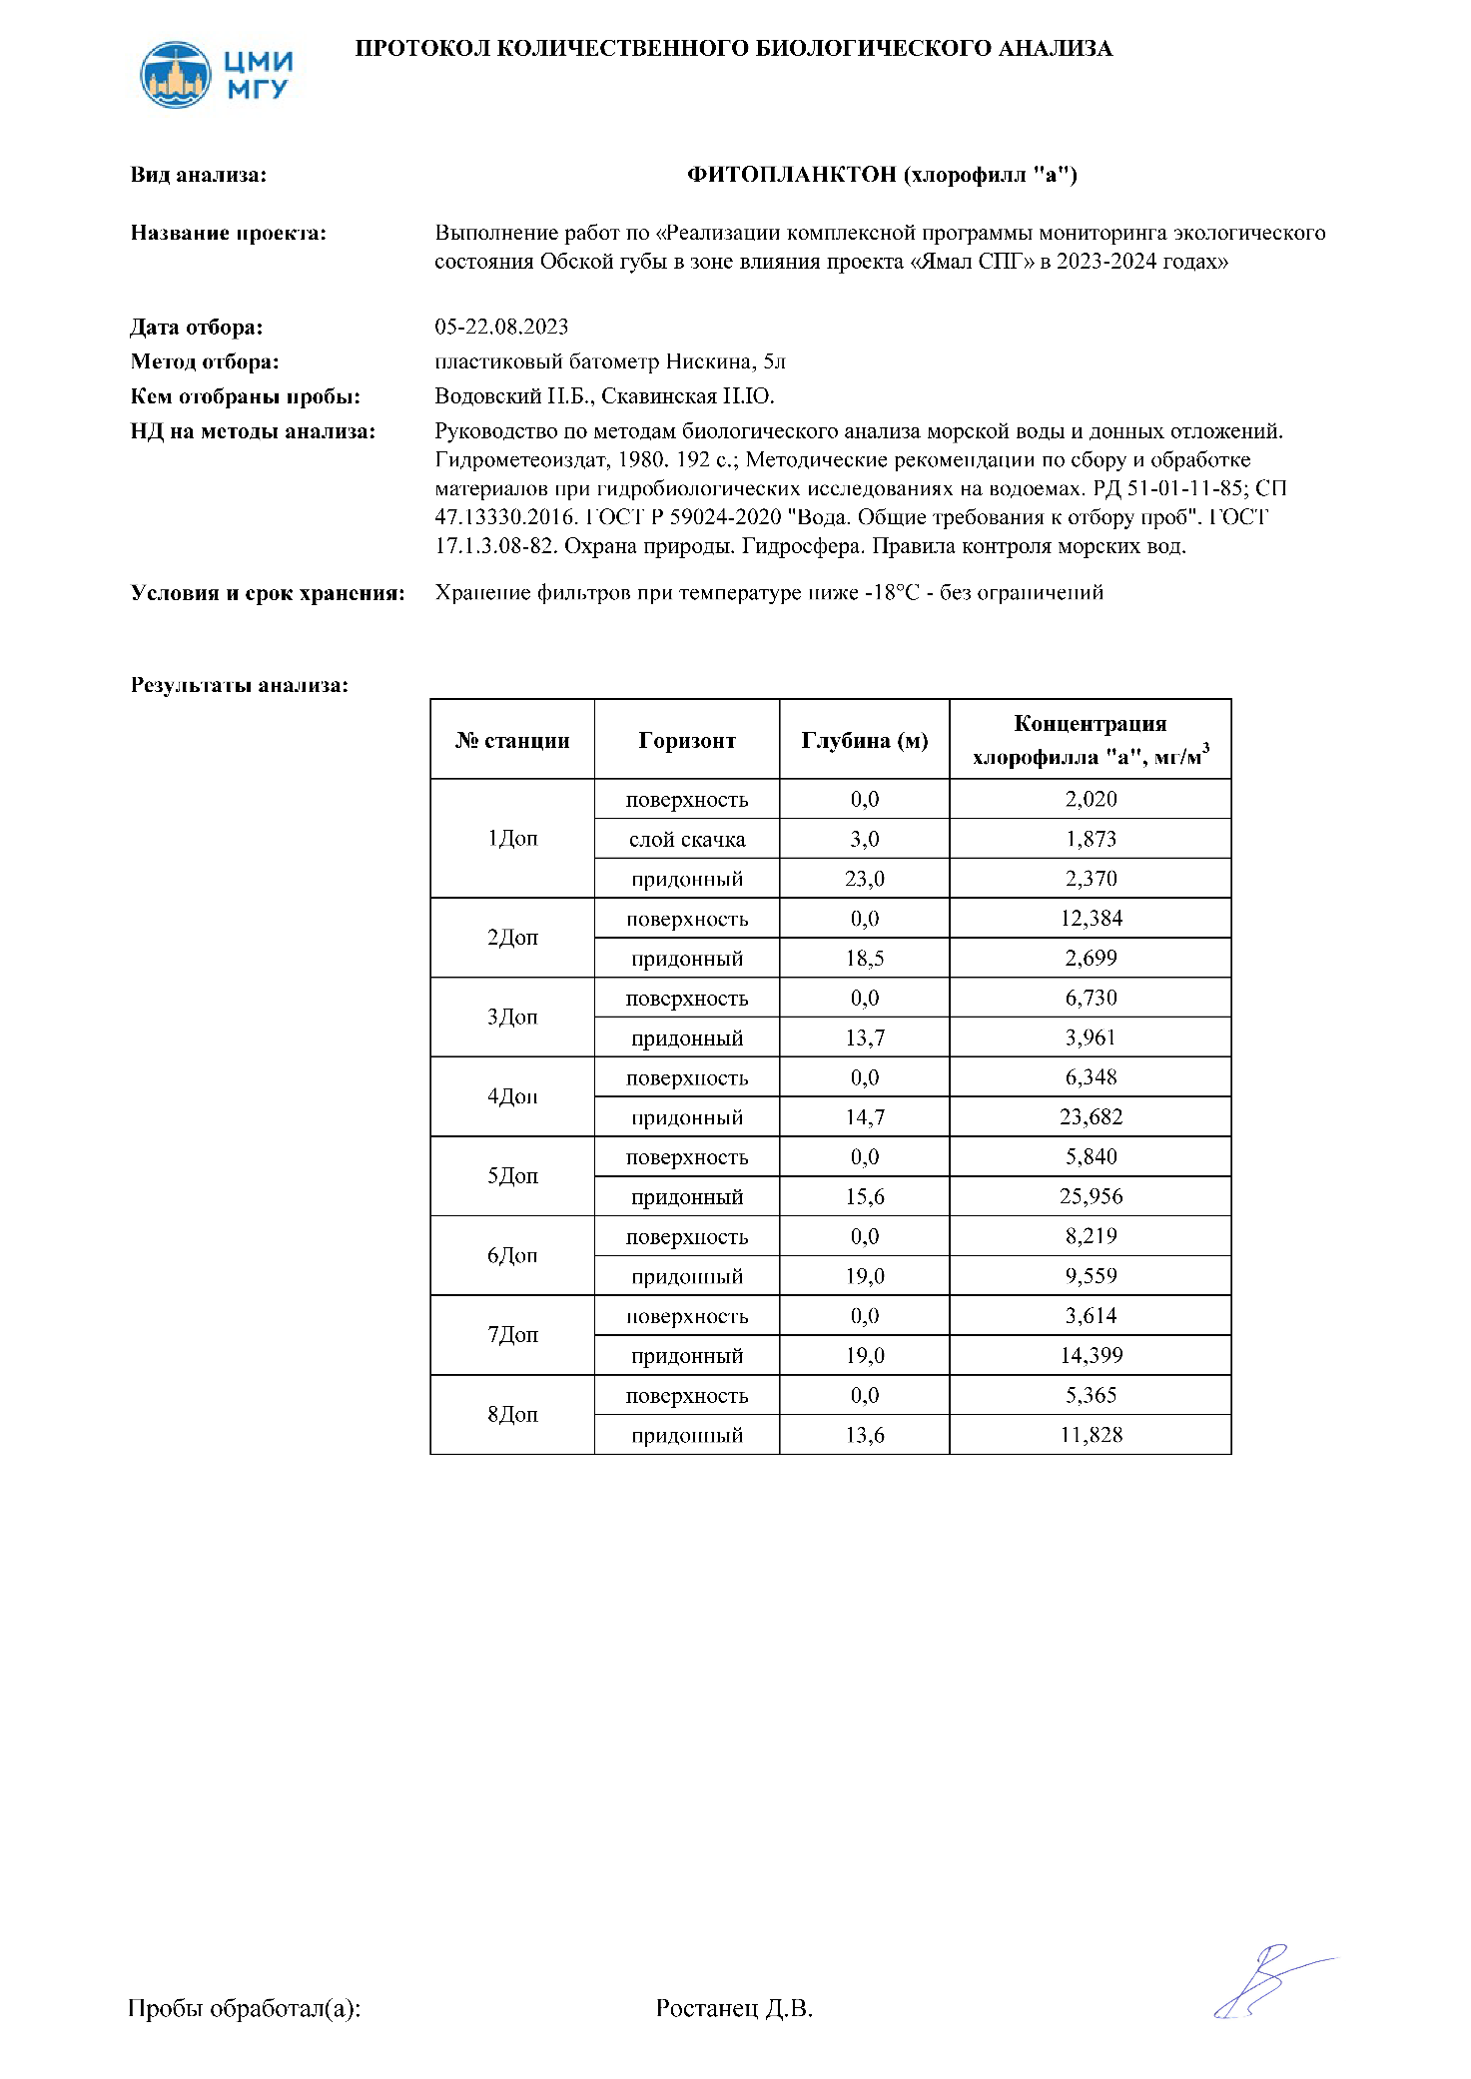

## Приложение У.3. Копии протоколов КБА проб первичной продукции

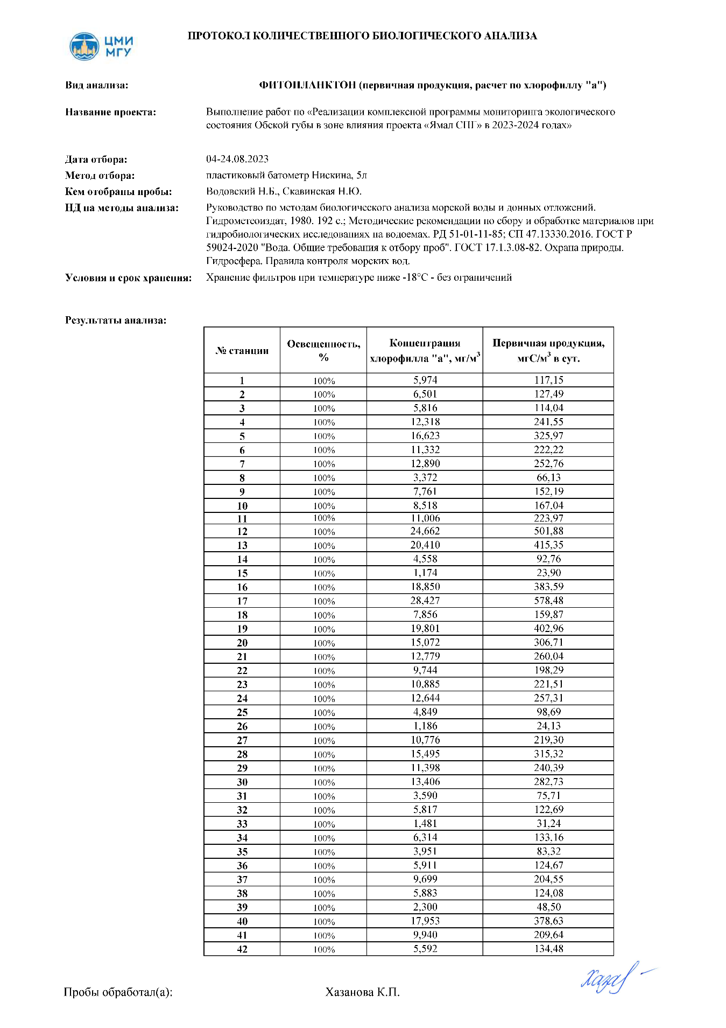

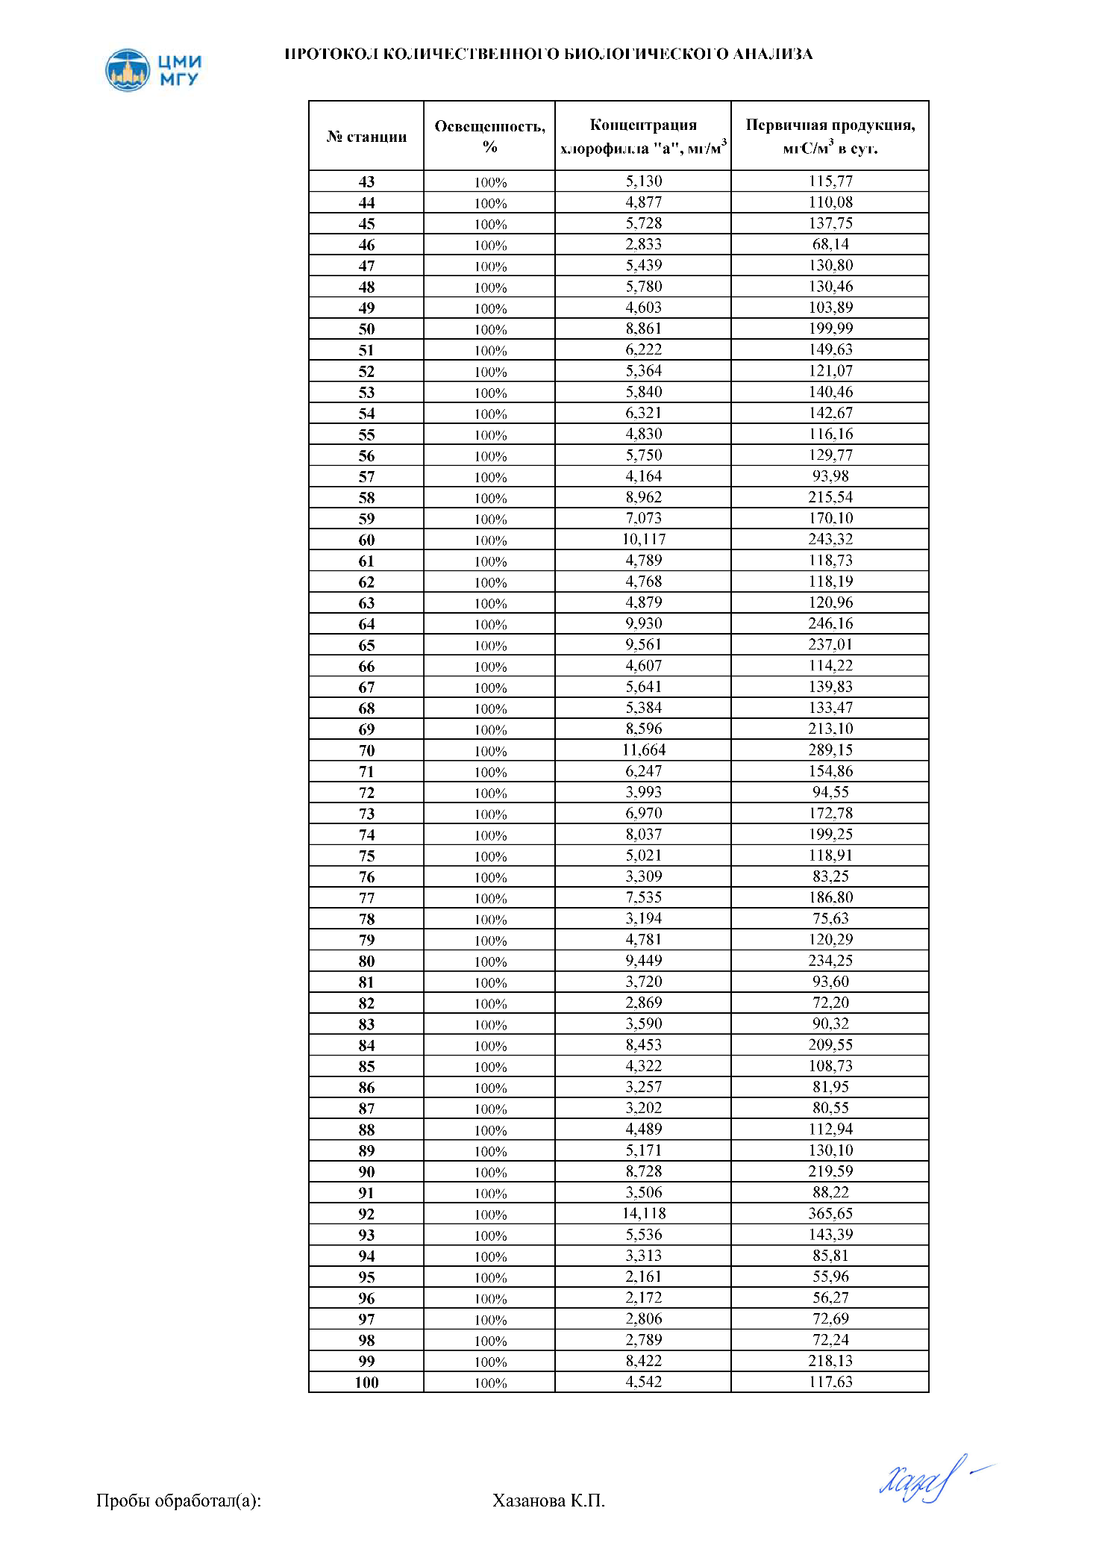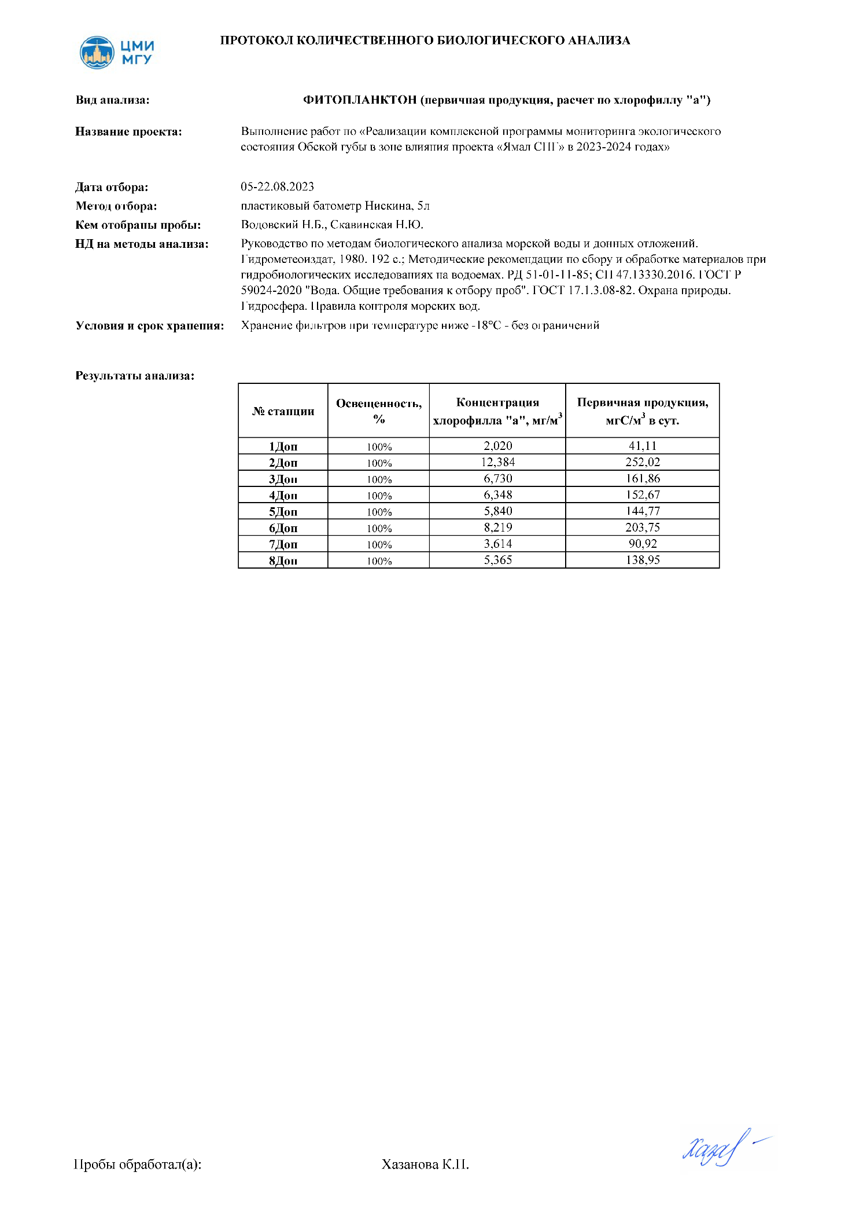

# 

# Приложение Ц. Гидробиологическая характеристика акватории

## Приложение Ц.1. Видовой состав фитопланктона Обской губы в августе 2023 г. (станции 1-50).

|  |  | **1** | **2** | **3** | **4** | **5** | **6** | **7** | **8** | **9** | **10** | **11** | **12** | **13** | **14** | **15** | **16** | **17** | **18** | **19** | **20** | **21** | **22** | **23** | **24** | **25** | **26** | **27** | **28** | **29** | **30** | **31** | **32** | **33** | **34** | **35** | **36** | **37** | **38** | **39** | **40** | **41** | **42** | **43** | **44** | **45** | **46** | **47** | **48** | **49** | **50** |
| --- | --- | --- | --- | --- | --- | --- | --- | --- | --- | --- | --- | --- | --- | --- | --- | --- | --- | --- | --- | --- | --- | --- | --- | --- | --- | --- | --- | --- | --- | --- | --- | --- | --- | --- | --- | --- | --- | --- | --- | --- | --- | --- | --- | --- | --- | --- | --- | --- | --- | --- | --- |
|  | **Ochrophyta (Bacillariophyceae)** |  |  |  |  |  |  |  |  |  |  |  |  |  |  |  |  |  |  |  |  |  |  |  |  |  |  |  |  |  |  |  |  |  |  |  |  |  |  |  |  |  |  |  |  |  |  |  |  |  |  |
| 1 | Achnanthes taeniata Grunow, 1880 | * |  |  | * |  |  | * | * | * |  |  |  |  |  |  |  |  |  |  |  |  |  |  |  |  |  |  |  |  |  |  |  |  |  |  |  |  |  |  |  |  |  |  |  |  |  |  |  |  |  |
| 2 | Actinocyclus normanii (Gregory) Hustedt, 1957 |  |  |  |  |  |  |  |  |  |  |  |  |  |  |  |  |  |  |  |  |  |  |  |  |  |  |  |  |  |  |  |  |  |  |  |  |  |  |  |  |  |  |  |  |  |  |  |  |  |  |
| 3 | Actinoptychus octonarius (Ehrenberg) Kützing, 1844 |  |  |  |  |  |  |  |  |  |  |  |  |  |  |  |  |  |  |  |  |  |  |  |  |  |  |  |  |  |  |  |  |  |  |  |  |  |  |  |  |  |  |  |  |  |  |  |  |  |  |
| 4 | Amphora ocellata Donkin, 1861 | * |  | * | * | * |  |  |  | * | * |  | * | * |  |  |  |  |  |  |  |  |  |  |  |  |  |  |  |  |  |  |  |  |  |  |  |  |  |  |  |  |  |  |  |  |  |  |  |  |  |
| 5 | Asterionella formosa Hassall, 1850 |  |  |  | * | * | * |  |  |  |  | * | * | * | * | * | * | * | * | * | * | * | * | * | * | * | * | * | * | * | * | * | * | * | * |  |  |  |  | * | * | * | * |  |  | * | * | * |  |  |  |
| 6 | Aulacoseira ambigua (Grunow) Simonsen, 1979 |  |  |  |  | * | * |  |  |  |  | * |  |  |  |  |  | * |  |  |  |  |  |  |  |  |  |  |  |  |  |  |  |  |  |  |  |  |  |  |  |  |  |  |  |  |  |  |  |  |  |
| 7 | Aulacoseira granulata (Ehrenberg) Simonsen, 1979 | * | * | * | * | * | * | * | * | * | * | * | * | * | * | * | * | * | * | * | * | * | * | * | * | * | * | * | * | * | * | * | * | * | * | * | * | * | * | * | * | * | * | * | * | * | * | * | * | * | * |
| 8 | Aulacoseira islandica (O. Müll.) Simonsen, 1979 |  |  |  |  | * | * |  |  |  |  | * |  |  |  |  |  | * |  |  |  |  |  |  |  |  |  |  |  |  |  |  |  |  |  | * | * | * | * |  |  |  |  | * | * | * | * | * | * | * | * |
| 9 | Aulacoseira italica (O. Müll.) Simonsen, 1979 | **\*** | **\*** | **\*** | **\*** |  |  | **\*** | **\*** | **\*** | **\*** |  | * | * | * | * | * |  | * | * | * | * | * | * | * | * | * | * | * | * | * |  |  |  |  |  |  |  |  |  |  |  |  |  |  |  |  |  |  |  |  |
| 10 | Aulacoseira subarctica (Otto Müller) E.Y.Haworth, 1990 |  |  |  |  | * | * |  |  |  |  | * |  |  |  |  |  | * |  |  |  |  |  |  |  |  |  |  |  |  |  |  |  |  |  |  |  |  |  |  |  |  |  |  |  |  |  |  |  |  |  |
| 11 | Chaetoceros debilis Cleve, 1894 |  |  | * |  | * |  | * | * |  |  |  |  |  |  |  |  | * |  |  |  |  |  |  |  |  |  |  |  |  |  |  |  |  |  |  |  |  |  |  |  |  |  |  |  |  |  |  |  |  |  |
| 12 | Chaetoceros decipiens Cleve, 1873 |  |  | * |  |  |  | * | * |  |  |  |  |  |  |  |  |  |  |  |  |  |  |  |  |  |  |  |  |  |  |  |  |  |  |  |  |  |  |  |  |  |  |  |  |  |  |  |  |  |  |
| 13 | Chaetoceros diadema (Ehrenberg) Gran, 1897 |  |  | * |  |  |  | * | * |  |  |  |  |  |  |  |  |  |  |  |  |  |  |  |  |  |  |  |  |  |  |  |  |  |  |  |  |  |  |  |  |  |  |  |  |  |  |  |  |  |  |
| 14 | Chaetoceros socialis H.S.Lauder, 1864 |  |  | * |  |  |  | * | * |  |  |  |  |  |  |  |  |  |  |  |  |  |  |  |  |  |  |  |  |  |  |  |  |  |  |  |  |  |  |  |  |  |  |  |  |  |  |  |  |  |  |
| 15 | Chaetoceros sp. spores |  |  | * |  |  |  | * | * |  |  |  |  |  |  |  | * |  | * | * | * | * | * | * | * | * | * | * | * | * | * |  |  |  |  | * | * | * | * |  |  |  |  | * | * |  |  |  | * | * | * |
| 16 | Chaetoceros wighamii Brightwell, 1856 |  |  | * |  |  |  | * | * |  |  |  | * | * | * | * | * |  | * | * | * | * | * | * | * | * | * | * | * | * | * |  |  |  |  | * | * | * | * |  |  |  |  | * | * |  |  |  | * | * | * |
| 17 | Cocconeis costata Gregory, 1855 | * | * | * | * |  |  | * | * | * |  |  | * | * | * | * | * |  |  | * |  |  |  | * |  |  | * |  |  | * |  |  |  |  |  | * |  |  | * |  |  |  |  | * |  |  |  |  | * |  |  |
| 18 | Cocconeis placentula Ehrenberg, 1838 | * |  |  | * |  |  | * | * | * |  |  |  |  |  |  |  |  |  |  |  |  |  |  |  |  |  |  |  |  |  |  |  |  |  |  |  |  |  |  |  |  |  |  |  |  |  |  |  |  |  |
| 19 | Cocconeis scutellum Ehrenberg, 1838 |  | * | * | * |  |  | * |  |  | * |  | * | * | * |  |  |  | * |  |  |  | * |  |  |  |  | * | * |  | * |  |  |  |  |  | * |  |  |  |  |  |  |  |  |  |  |  |  | * |  |
| 20 | Coscinodiscus sp. |  | * | * |  |  |  |  |  |  |  |  | * |  | * |  | * |  |  | * |  | * |  |  |  | * | * |  |  |  | * |  |  |  |  |  |  |  |  |  |  |  |  |  |  |  |  |  |  |  |  |
| 21 | Cyclostephanos dubius (Hused) Round, 1988 |  |  |  |  |  |  |  |  |  |  |  |  |  |  |  |  |  |  |  |  |  |  |  |  |  |  |  |  |  |  | * | * | * | * |  |  |  |  | * | * | * | * |  |  | * | * | * |  |  |  |
| 22 | Cyclotella comta (Ehrenberg)Kützing, 1849 |  |  |  |  |  | * |  |  |  |  | * |  |  |  |  |  | * |  |  |  |  |  |  |  |  |  |  |  |  |  | * | * | * | * |  |  |  |  | * | * | * | * |  |  | * | * | * |  |  |  |
| 23 | Cyclotella meneghiniana Kützing, 1844 |  |  |  |  | * |  |  |  |  |  |  |  |  |  |  |  |  |  |  |  |  |  |  |  |  |  |  |  |  |  |  |  |  |  |  |  |  |  |  |  |  |  |  |  |  |  |  |  |  |  |
| 24 | Cymbella cistula (Ehrenberg) O.Kirchner, 1878 |  |  |  |  |  |  |  |  |  |  |  |  |  |  |  |  |  |  |  |  |  |  |  |  |  |  |  |  |  |  |  |  |  |  |  |  |  |  |  |  |  |  |  |  |  |  |  |  |  |  |
| 25 | Diatoma tenuis C.Agardh, 1812 |  |  |  |  | * | * |  |  |  |  | * |  |  |  |  |  |  |  |  |  |  |  |  |  |  |  |  |  |  |  |  |  |  |  |  |  |  |  |  |  |  |  |  |  |  |  |  |  |  |  |
| 26 | Diploneis interrupta (Kützing) Cleve, 1894 | * | * |  |  |  |  |  |  |  |  |  |  |  | * | * |  |  |  | * | * |  |  | * | * |  | * | * | * |  |  | * | * | * | * |  | * | * | * |  |  |  |  | * |  |  |  |  |  |  | * |
| 27 | Entomoneis sp. |  |  |  |  |  |  |  |  |  |  |  |  |  |  |  |  |  |  |  |  |  |  |  |  |  |  |  |  |  |  |  |  |  |  |  |  |  |  |  |  |  |  |  |  |  |  |  |  |  |  |
| 28 | Fragilaria construens (Ehrenberg) Grunow, 1862 | * | * |  |  |  |  |  |  |  |  |  | * | * | * |  |  |  | * |  |  |  |  |  |  |  |  |  |  |  | * |  |  |  |  |  |  |  |  |  |  |  |  |  |  |  |  |  |  |  |  |
| 29 | Fragilaria crotonensis Kitton, 1869 |  |  |  |  | * | * |  |  |  |  | * |  |  |  |  |  | * |  |  |  |  |  |  |  |  |  |  |  |  |  |  |  |  |  | * |  | * |  |  |  | * | * |  | * | * | * | * |  | * |  |
| 30 | Fragilariopsis cylindrus (Grunow) Krieger, 1954 | * | * |  |  |  |  |  |  |  |  |  |  | * | * |  | * |  |  |  | * |  | * |  |  |  |  |  | * | * |  | * | * |  |  |  |  |  |  |  |  |  |  |  |  |  |  |  |  |  |  |
| 31 | Fragilariopsis oceanica (Cleve) Hasle, 1965 | * |  |  |  |  |  |  |  |  |  |  |  |  |  |  |  |  | * |  |  |  |  | * | * | * | * | * |  |  | * |  |  |  |  |  |  |  |  |  |  |  |  |  |  |  |  |  |  |  |  |
| 32 | Frustulia ventricosa C.Agardh, 1827 |  |  |  |  |  |  |  |  |  |  |  |  |  |  |  |  |  |  |  |  |  |  |  |  |  |  |  |  |  |  |  |  |  |  |  |  |  |  |  |  |  |  |  |  |  |  |  |  |  |  |
| 33 | Gomphonema acuminatum Ehrenberg, 1832 |  |  |  |  |  |  |  |  |  |  |  |  |  |  |  |  |  |  |  |  |  |  |  |  |  |  |  |  |  |  | * | * |  |  |  |  | * |  |  | * | * |  |  |  | * | * |  | * |  | * |
| 34 | Gomphonema olivaceum (Lyngbye ) Desmazieres, 1825 |  |  |  |  |  |  |  | * | * | * |  |  |  |  |  |  |  |  |  |  |  |  |  |  |  |  |  |  |  |  |  |  |  |  |  |  |  |  | * |  |  |  |  |  |  |  |  |  |  |  |
| 35 | Lindavia bodanica (Eulenstein ex Grunow) Nakov et al., 2015 |  |  |  |  | * |  |  |  |  |  |  |  |  |  |  |  | * |  |  |  |  |  |  |  |  |  |  |  |  |  |  |  |  |  |  |  |  |  |  |  |  |  |  |  |  |  |  |  |  |  |
| 36 | Melosira arctica (Ehrenberg) Ralfs in Pritchard, 1861 | * | * | * | * |  |  | * |  |  |  |  | * |  |  |  |  |  |  |  | * | * |  |  |  |  |  |  | * | * | * | * | * | * | * |  | * |  | * | * | * | * | * | * |  | * | * | * |  | * |  |
| 37 | Melosira juergensi C. Agardh, 1824 |  |  |  |  |  |  |  | * |  |  |  |  | * | * | * | * |  |  |  |  |  |  | * |  |  |  |  | * |  |  |  |  |  |  |  |  |  |  |  |  |  | * |  |  | * |  | * |  |  |  |
| 38 | Melosira moniliformis (O.F.Müller) C.Agardh, 1824 |  |  |  |  |  |  |  |  |  |  |  |  |  |  |  |  |  |  |  |  |  |  |  |  |  |  |  |  |  |  |  |  |  |  | * |  |  | * |  |  |  |  |  | * |  |  |  |  | * |  |
| 39 | Melosira varians Ag., 1827 |  |  |  |  |  |  |  |  |  |  |  |  |  |  |  |  |  |  |  |  |  |  |  |  |  |  |  |  |  |  |  |  | * |  |  |  |  |  | * | * |  |  | * |  |  |  | * | * |  | * |
| 40 | Navicula abrupta (W.Gregory) Donkin, 1870 |  |  |  |  |  |  |  |  | * |  |  | * | * |  | * |  |  | * | * |  |  | * |  |  |  | * | * |  | * | * |  |  |  |  |  |  | * |  |  |  |  |  |  |  |  |  |  |  |  |  |
| 41 | Navicula perlucens Østrup, 1895 |  |  |  |  |  |  |  |  |  |  |  |  |  |  |  |  |  |  |  |  |  |  |  |  |  |  |  |  |  |  |  |  |  |  |  |  |  |  |  |  |  | * |  |  | * | * |  |  |  |  |
| 42 | Navicula radiosa Kützing, 1844 |  |  |  |  |  |  | * | * |  |  |  |  |  |  |  |  |  |  |  |  |  |  |  |  |  |  |  |  |  |  |  |  |  |  |  |  |  |  |  |  |  |  |  |  |  |  |  |  |  |  |
| 43 | Navicula sp.1 |  |  |  |  |  | * |  |  | * |  |  |  |  | * | * |  | * | * |  | * | * |  | * | * | * | * | * |  | * | * |  |  |  |  | * |  |  |  |  |  |  |  |  |  |  |  |  | * |  |  |
| 44 | Navicula sp.2 |  |  |  |  | * |  | * |  | * |  |  |  |  |  |  |  |  |  |  |  |  |  |  |  |  |  |  |  |  |  |  |  |  |  |  |  |  |  |  |  |  |  |  |  |  |  |  |  |  |  |
| 45 | Navicula transitans var. transitans Cleve, 1883 |  |  |  |  |  |  |  |  |  |  |  |  |  |  |  |  |  |  |  |  |  |  |  |  |  |  |  |  |  |  |  |  |  |  |  | * |  |  |  |  |  |  |  |  |  |  | * | * |  | * |
| 46 | Navicula vanhoeffenii Gran, 1897 | * | * | * | * |  |  | * | * | * | * |  | * | * | * |  | * |  |  | * |  |  |  | * |  |  | * |  | * |  |  |  |  |  |  |  |  |  |  |  |  |  |  |  | * |  |  |  |  |  |  |
| 47 | Nitzchia sp. |  | * |  |  | * |  | * | * |  | * |  | * | * |  | * |  | * | * |  |  |  | * | * |  | * | * | * |  | * |  |  |  |  |  |  |  |  |  |  |  |  |  | * | * |  |  |  |  | * |  |
| 48 | Nitzschia acicularis (Kützing) W.Smith, 1853 |  |  |  |  |  | * |  |  |  |  | * |  |  |  |  |  | * |  |  |  |  |  |  |  |  |  |  |  |  |  | * |  |  |  |  |  | * |  |  |  |  | * |  |  | * | * | * |  |  | * |
| 49 | Nitzschia closterium f. minutissima Allen & Nelson, 1910 |  |  | * | * |  |  |  |  | * | * |  | * |  |  | * |  |  |  | * | * |  | * |  | * | * |  |  | * | * |  |  |  |  |  |  |  |  | * |  |  |  |  |  |  |  |  |  | * |  |  |
| 50 | Nitzschia longissima (Brébisson) Ralfs, 1861 | * | * |  | * |  |  |  |  |  |  |  |  |  |  |  |  |  |  |  |  |  |  |  |  |  |  |  |  |  |  |  |  |  |  |  | * |  |  |  |  |  |  | * |  |  |  |  | * |  | * |
| 51 | Nitzschia palea (Kützing) W.Smith, 1856 |  |  |  |  |  |  |  |  |  |  |  |  |  |  |  |  |  |  |  |  |  |  |  |  |  |  |  |  |  |  |  |  |  |  |  |  | * |  | * | * | * |  | * |  | * |  |  |  |  |  |
| 52 | Paralia sulcata (Ehrenberg) Cleve, 1873 | * |  | * | * |  |  |  |  |  |  |  | * | * | * | * | * |  | * | * | * | * | * | * | * | * | * | * | * | * | * |  |  |  |  |  |  |  |  |  |  |  |  |  |  |  |  |  |  |  |  |
| 53 | Pinnularia gibba Ehrenberg, 1843 |  |  |  |  |  |  |  |  |  |  |  |  |  |  |  |  |  |  |  |  |  |  |  |  |  |  |  |  |  |  |  |  |  |  |  | * |  | * |  | * | * |  |  |  |  | * |  | * | * |  |
| 54 | Placoneis placentula (Ehrenberg) Mereschkowsky, 1903 |  |  |  |  | * | * |  |  |  |  |  |  |  |  |  |  | * |  |  |  |  |  |  |  |  |  |  |  |  |  |  |  |  |  |  |  |  |  |  |  |  |  |  |  |  |  |  |  |  |  |
| 55 | Skeletonema costatum (Grév.) Cleve, 1878 | * |  | * | * |  |  |  |  |  |  |  | * | * | * | * | * |  | * | * | * | * | * | * | * | * | * | * | * | * | * |  |  |  |  |  |  |  |  |  |  |  |  |  |  |  |  |  |  |  |  |
| 56 | Stephanodiscus dubius Hustedt, 1928 |  |  |  |  | * | * |  |  |  |  | * |  |  |  |  |  | * |  |  |  |  |  |  |  |  |  |  |  |  |  |  |  |  |  |  |  |  |  |  |  |  |  |  |  |  |  |  |  |  |  |
| 57 | Stephanodiscus hantzschii Grunow, 1886 |  |  |  |  | * | * |  |  |  |  | * |  |  |  |  |  | * |  |  |  |  |  |  |  |  |  |  |  |  |  |  |  |  |  |  |  |  |  |  |  |  |  |  |  |  |  |  |  |  |  |
| 58 | Stephanodiscus pusillus (Grunow) Willi Krieger |  |  |  |  | * | * |  |  |  |  | * |  |  |  |  |  | * |  |  |  |  |  |  |  |  |  |  |  |  |  |  |  |  |  |  |  |  |  |  |  |  |  |  |  |  |  |  |  |  |  |
| 59 | Surirella biseriata Brébisson, 1835 |  |  |  |  |  |  |  |  |  |  |  |  |  |  |  |  |  |  |  |  |  |  |  |  |  |  |  |  |  |  |  |  |  |  |  |  |  |  |  |  |  |  |  |  |  |  |  |  |  |  |
| 60 | Surirella crumena Brébisson ex Kützing, 1849 |  |  |  |  |  |  |  |  |  |  |  |  |  |  |  |  |  |  |  |  |  |  |  |  |  |  |  |  |  |  |  |  |  |  |  |  |  |  |  |  |  |  |  |  |  |  |  |  |  |  |
| 61 | Surirella minuta Brébisson, 1849 |  |  |  | * |  |  | * | * |  | * |  |  |  |  |  |  |  |  |  |  |  |  |  |  |  |  |  |  |  |  |  |  |  |  |  |  |  |  |  |  |  |  |  |  |  |  |  |  |  |  |
| 62 | Tabellaria fenestrata Lyngbye Kützing 1844 |  |  |  |  |  | * |  |  |  |  |  |  |  |  |  |  | * |  |  |  |  |  |  |  |  |  |  |  |  |  |  |  |  |  |  |  |  |  |  |  |  |  |  |  |  |  |  |  |  |  |
| 63 | Tabellaria flocculosa (Roth) Kützing, 1844 |  |  |  |  | * |  |  |  |  |  | * |  |  |  |  |  |  |  |  |  |  |  |  |  |  |  |  |  |  |  |  |  |  |  |  |  |  |  |  |  |  |  |  |  |  |  |  |  |  |  |
| 64 | Thalassionema nitzschioides (Grunow) Mereschkowsky, 1902 |  |  |  |  |  |  |  | * | * | * |  |  |  |  |  |  |  |  |  |  |  |  |  |  |  |  |  |  |  |  |  |  |  |  |  |  |  |  |  |  |  |  |  |  |  |  |  |  |  |  |
| 65 | Thalassiosira antarctica Comber, 1896 |  |  |  |  |  |  | * |  | * |  |  |  |  |  |  |  |  |  |  |  |  |  |  |  |  |  |  |  |  |  |  |  |  |  |  |  |  |  |  |  |  |  |  |  |  |  |  |  |  |  |
| 66 | Thalassiosira baltica (Grunow) Ostenfeld, 1901 |  |  |  |  |  |  |  |  |  |  |  |  |  |  |  |  |  |  |  |  |  |  |  |  |  |  |  |  |  |  | * | * | * | * | * | * | * | * | * | * | * | * | * | * | * | * | * | * | * | * |
| 67 | Thalassiosira gravida P.T. Cleve, 1896 |  |  | * |  |  |  | * | * | * |  |  |  |  |  |  |  |  |  |  |  |  |  |  |  |  |  |  |  |  |  |  |  |  |  |  |  |  |  |  |  |  |  |  |  |  |  |  |  |  |  |
| 68 | Thalassiosira ignota Makarova, 1975 | * | * | * | * |  |  | * | * | * | * |  | * | * | * | * | * |  | * | * | * | * | * | * | * | * | * | * | * | * | * | * | * | * | * | * | * | * | * | * | * | * | * | * | * | * | * | * | * | * | * |
| 69 | Thalassiosira nordenskioeldii Cleve, 1873 | * | * | * | * |  |  | * | * | * | * |  |  |  |  |  |  |  |  |  |  |  |  |  |  |  |  |  |  |  |  |  |  |  |  |  |  |  |  |  |  |  |  |  |  |  |  |  |  |  |  |
| 70 | Ulnaria acus (Kützing) M.Aboal, 2003 |  |  |  |  |  |  |  |  |  |  | * |  |  |  |  |  |  |  |  |  |  |  |  |  |  |  |  |  |  |  |  |  |  |  |  |  |  |  |  |  |  |  |  |  |  |  | * |  |  |  |
|  | **Chrysophyceae** |  |  |  |  |  |  |  |  |  |  |  |  |  |  |  |  |  |  |  |  |  |  |  |  |  |  |  |  |  |  |  |  |  |  |  |  |  |  |  |  |  |  |  |  |  |  |  |  |  |  |
| 71 | Ochromonas spp |  |  | * |  |  |  | * | * |  |  |  | * | * | * | * |  |  |  |  |  |  |  |  |  |  |  |  |  |  |  |  |  |  |  |  |  |  |  |  |  |  |  |  |  |  |  |  |  |  |  |
|  | **Chlorophyta** |  |  |  |  |  |  |  |  |  |  |  |  |  |  |  |  |  |  |  |  |  |  |  |  |  |  |  |  |  |  |  |  |  |  |  |  |  |  |  |  |  |  |  |  |  |  |  |  |  |  |
| 72 | Actinastrum hantzschii Lagerheim, 1882 |  |  |  |  |  |  |  |  |  |  | * |  |  |  |  |  |  |  |  |  |  |  |  |  |  |  |  |  |  |  |  |  |  |  |  |  |  |  |  |  |  |  |  |  |  |  |  |  |  |  |
| 73 | Ankistrodesmus arcuatus Korshikov, 1953 |  |  |  |  | * | * |  |  |  |  | * |  |  |  |  |  | * |  |  |  |  |  |  |  |  |  |  |  |  |  |  |  |  |  |  |  |  |  |  |  |  |  |  |  |  |  |  |  |  |  |
| 74 | Ankistrodesmus falcatus (Corda) Ralfs, 1848 |  |  |  |  |  |  |  |  |  |  |  | * | * | * | * | * |  | * | * | ** | * | * | ** | ** | * | * | * | * | * | * | * | * |  | * |  |  | * | * |  | * | * |  | * | * | * |  | * |  |  |  |
| 75 | Ankistrodesmus fusiformis Corda, 1838 |  |  |  |  |  |  |  |  |  |  |  |  |  |  |  |  |  |  |  |  |  |  |  |  |  |  |  |  |  |  |  |  |  |  |  |  |  |  |  |  |  |  |  |  |  |  |  |  |  |  |
| 76 | Binuclearia palhinhae P.González, 1950 |  |  |  |  |  |  |  |  |  |  |  |  |  |  |  |  |  |  |  |  |  |  |  |  |  |  |  |  |  |  |  |  |  |  |  |  |  |  |  |  |  |  |  |  |  |  |  |  |  |  |
| 77 | Binuclearia lauterbornii (Schmidle) Proschkina-Lavrenko, 1966 |  |  |  |  | * | * |  |  |  |  | * |  |  |  |  |  | * |  |  |  |  |  |  |  |  |  |  |  |  |  |  |  |  |  |  |  |  |  |  |  |  |  |  |  |  |  |  |  |  |  |
| 78 | Chlamydomonas globosa J.W.Snow, 1903 |  |  |  |  | * |  |  |  |  |  | * |  |  |  |  |  |  |  |  |  |  |  |  |  |  |  |  |  |  |  |  |  |  |  |  |  |  |  |  |  |  |  |  |  |  |  |  |  |  |  |
| 79 | Coelastrum astroideum De Notaris, 1867 |  |  |  |  |  |  |  |  |  |  |  |  |  |  |  |  |  |  |  |  |  |  |  |  |  |  |  |  |  |  |  |  |  |  |  |  |  |  |  |  |  |  |  |  |  |  |  |  |  |  |
| 80 | Closterium moniliferum Ehrenberg ex Ralfs, 1848 |  |  |  |  |  |  |  |  |  |  |  |  |  |  |  |  |  |  |  |  |  |  |  |  |  |  |  |  |  |  |  |  |  |  |  |  |  |  |  |  |  |  |  |  |  |  |  |  |  |  |
| 81 | Coenocystis planktonica Korshikov |  |  |  |  |  |  |  |  |  |  |  |  |  |  |  |  |  |  |  |  |  |  |  |  |  |  |  |  |  |  |  |  |  |  |  |  |  |  |  |  |  |  |  |  |  |  |  |  |  |  |
| 82 | Crucigenia quadrata Morren, 1830 |  |  |  |  |  |  |  |  |  |  |  | * | * | * | * | * |  | * | * | * |  | * |  |  | * | * | * | * | * |  |  |  |  |  |  |  |  |  |  |  |  |  |  |  |  |  |  |  |  |  |
| 83 | Crucigera irregularis Bush, 1905 |  |  |  |  |  |  |  |  |  |  |  |  |  |  |  |  |  |  |  |  |  |  |  |  |  |  |  |  |  |  |  |  |  |  |  |  |  |  |  |  |  |  |  |  |  |  |  |  |  |  |
| 84 | Crucigenia tetrapedia (Kirchner) Kuntze, 1898 |  |  |  |  |  |  |  |  |  |  |  |  |  |  |  | * |  | * | * | * | ** | * | ** | ** |  | ** |  | * | * | * |  | * | * |  | * |  |  | * | * |  |  |  | * |  |  |  |  | * | * | * |
| 85 | Desmodesmus intermedius (Chodat) E.Hegewald, 2000 |  |  |  |  | * | * |  |  |  |  |  |  |  |  |  |  |  |  |  |  |  |  |  |  |  |  |  |  |  |  |  |  |  | * |  | * | * |  |  |  |  | * |  |  |  | * |  |  |  |  |
| 86 | Desmodesmus magnus (Meyen) Tsarenko, 2000 |  |  |  |  |  |  |  |  |  |  |  |  |  |  |  |  |  |  |  |  |  |  |  |  |  |  |  |  |  |  |  |  |  |  |  |  |  |  |  |  |  |  |  | * |  |  |  |  | * |  |
| 87 | Desmodesmus spinosus (Chodat) E.Hegewald, 2000 |  |  |  |  |  |  |  |  |  |  | * |  |  |  |  |  |  |  |  |  |  |  |  |  |  |  |  |  |  |  |  |  |  |  |  |  |  |  |  |  |  |  |  |  |  |  |  |  |  |  |
| 88 | Dictyosphaerium elegans H. Bachm., 1913 |  |  |  |  |  | * |  |  |  |  |  |  |  |  |  |  | * |  |  |  |  |  |  |  |  |  |  |  |  |  |  |  |  |  |  |  |  |  |  |  |  |  |  |  |  |  |  |  |  |  |
| 89 | Dictyosphaerium subsolitarium Van Goor, 1924 |  |  |  |  |  |  |  |  |  |  |  |  |  |  |  |  |  |  |  |  |  |  |  |  |  |  |  |  |  |  |  |  |  |  |  |  |  |  |  |  |  |  |  |  |  |  |  |  |  |  |
| 90 | Golenkiniopsis solitaria (Korshikov) Korshikov, 1953 |  |  |  |  |  |  |  |  |  |  | * | * | * | * | * | * |  |  | * | * | * | ** |  |  |  | * | ** | * |  |  |  |  |  |  | * |  | * |  |  | * |  |  | * |  | * |  |  |  |  | * |
| 91 | Hegewaldia parvula (Woronichin) Pröschold, C.Bock, W.Luo & L Krienitz, 2010 |  |  |  |  |  |  |  |  |  |  |  |  |  |  |  |  |  |  |  |  |  |  |  |  |  |  |  |  |  |  |  |  |  |  |  |  |  |  |  |  |  |  |  |  |  |  |  |  |  |  |
| 92 | Kirchneriella lunaris (Kirchner) Mubius, 1894 |  |  |  |  |  |  |  |  |  |  |  |  |  |  |  |  |  |  |  |  |  |  |  |  |  |  |  |  |  |  |  |  |  |  |  |  |  |  |  |  |  |  |  |  |  |  |  |  |  |  |
| 93 | Lagerheimia genevensis (Chodat) Chodat, 1895 |  |  |  |  |  | * |  |  |  |  |  |  |  |  |  |  |  |  |  |  |  |  |  |  |  |  |  |  |  |  |  |  |  |  |  |  |  |  |  |  |  |  |  |  |  |  |  |  |  |  |
| 94 | Lagerheimia subsalsa Lemmermann, 1898 |  |  |  |  | * |  |  |  |  |  | * |  |  |  |  |  | * |  |  |  |  |  |  |  |  |  |  |  |  |  |  |  |  |  |  |  |  |  |  |  |  |  |  |  |  |  |  |  |  |  |
| 95 | Lemmermannia triangularis (Chodat) C.Bock & Krienitz, 2013 |  |  |  |  |  |  |  |  |  |  |  |  |  |  |  |  |  |  |  |  |  |  |  |  |  |  |  |  |  |  |  |  |  |  |  |  |  |  |  |  |  |  |  |  |  |  |  |  |  |  |
| 96 | Micractinium pusillum Fresenius, 1858 |  |  |  |  |  |  |  |  |  |  | * |  |  |  |  |  | * |  |  |  |  |  |  |  |  |  |  |  |  |  |  |  |  |  |  |  |  |  |  |  |  |  |  |  |  |  |  |  |  |  |
| 97 | Monoraphidium contortum (Thuret in Brébisson) Komárková- Legnerová 1969 |  |  |  |  |  | * |  |  |  |  |  |  |  |  |  | * |  | * | * | * | * | * | * | * | * | * | * | * | * | * | * | * | * |  |  |  |  | * |  |  | * |  |  |  |  | * | * |  |  | * |
| 98 | Monoraphidium convolutum (Corda) Komárková-Legnerová, 1969 |  |  |  |  | * |  |  |  |  |  |  | * | * | * | * | * |  | * | * | * | * |  | ** | * | * | * |  | * |  | * |  |  |  |  | * | * |  |  |  |  |  |  |  |  |  |  |  | * | * |  |
| 99 | Monoraphidium komarkovae Nygaard 1979 |  |  |  |  |  | * |  |  |  |  | * | * |  |  |  | * | * |  |  | * |  | * |  | * |  |  | * |  | * |  |  |  |  | * |  |  |  |  | * | * |  |  |  |  |  | * |  |  |  |  |
| 100 | Oocystis sp. |  |  |  |  | * | * |  |  |  |  |  |  |  |  |  |  | * |  |  |  |  |  |  |  |  |  |  |  |  |  |  |  |  |  |  |  |  |  |  |  |  |  |  |  |  |  |  |  |  |  |
| 101 | Pediastrum biradiatum Meyen, 1829 |  |  |  |  |  |  |  |  |  |  |  |  |  |  |  |  | * |  |  |  |  |  |  |  |  |  |  |  |  |  |  |  |  |  |  |  |  |  |  |  |  |  |  |  |  |  |  |  |  |  |
| 102 | Pediastrum duplex, Meyen 1829 |  |  |  |  | * | * |  |  |  |  | * |  | * | * | * | * | * | * | * | * | * | * | * | * | * | * | * | * | * | * |  | * |  |  | * | * | * | * |  |  |  |  | * | * | * |  |  | * | * | * |
| 103 | Pandorina morum, O.F. Müller) Bory 1824 | * | * | * | * |  |  | * | * | * | * |  | * | * | * | * |  |  |  |  |  |  |  |  |  |  |  |  |  |  |  | * | * | * | * | * |  |  |  | * |  | * | * |  |  |  | * | * |  |  |  |
| 104 | Pseudopediastrum boryanum (Turpin) E.Hegewald, 2005 |  |  |  |  |  | * |  |  |  |  |  |  |  |  |  |  | * |  |  |  |  |  |  |  |  |  |  |  |  |  |  |  |  |  |  |  |  |  |  |  |  |  |  |  |  |  |  |  |  |  |
| 105 | Scenedesmus quadricauda (Turpin) Brébisson, 1835 |  |  |  |  |  | * |  |  |  |  |  | * | * |  | * | * | * | * | * |  | * | * |  | * |  | * | * | * | * |  |  |  |  | * |  | * | * | * |  |  |  |  |  | * |  |  |  |  | * | * |
| 106 | Scenedesmus acuminatus (Lagerheim) Chodat, 1902 |  |  |  |  |  |  |  |  |  |  |  | * |  | * | * |  |  | * | * | ** | * |  | * | * | * | * |  |  |  | * |  | * |  |  |  |  |  |  |  | * |  | * | * | * |  | * |  | * |  |  |
| 107 | Selenastrum bibraianum Reinsch, 1866 |  |  |  |  |  |  |  |  |  |  |  |  |  |  |  |  |  |  |  |  |  |  |  |  |  |  |  |  |  |  |  |  |  |  |  |  |  |  |  |  |  |  |  |  |  |  |  |  |  |  |
| 108 | Tetradesmus obliquus (Turpin) M.J.Wynne, 2016 |  |  |  |  | * |  |  |  |  |  | * |  |  |  |  |  | * |  |  |  |  |  |  |  |  |  |  |  |  |  |  |  |  |  |  |  |  |  |  |  |  |  |  |  |  |  |  |  |  |  |
| 109 | Tetraedron caudatum (Corda) Hansgirg, 1888 |  |  |  |  | * |  |  |  |  |  |  |  |  |  |  |  |  |  |  |  |  |  |  |  |  |  |  |  |  |  | * |  | * |  |  |  |  |  |  |  | * |  |  |  | * |  |  |  |  |  |
| 110 | Tetrastrum staurogeniiforme (Schröder) Lemmermann, 1900 |  |  |  |  | * | * |  |  |  |  |  |  |  |  |  |  | * |  |  |  |  |  |  |  |  |  |  |  |  |  |  |  |  |  |  |  |  |  |  |  |  |  |  |  |  |  |  |  |  |  |
| 111 | Tetrastrum triacanthum Korshikov, 1939 |  |  |  |  |  | * |  |  |  |  |  |  |  |  |  |  |  |  |  |  |  |  |  |  |  |  |  |  |  |  |  | * | * | * |  |  |  |  | * | * |  | * |  |  | * | * | * |  |  |  |
| 112 | Treubaria setigera (W.Archer) G.M.Smith, 1933 |  |  |  |  |  |  |  |  |  |  |  |  |  |  |  |  |  |  |  |  |  |  |  |  |  |  |  |  |  |  |  |  |  |  |  |  |  |  |  |  |  |  |  |  |  |  |  |  |  |  |
|  | **Cyanobacteria** |  |  |  |  |  |  |  |  |  |  |  |  |  |  |  |  |  |  |  |  |  |  |  |  |  |  |  |  |  |  |  |  |  |  |  |  |  |  |  |  |  |  |  |  |  |  |  |  |  |  |
| 113 | Anabaena sp. | * |  |  | * |  |  | * |  | * | * |  | * | * | * | * | * |  | * | * | * | * | * | * | * | * | * | * | * | * | * | * | * | * | * |  |  |  |  | * | * | * | * |  |  | * | * | * |  |  |  |
| 114 | Aphanizomenon flosaquae Ralfs ex Bornet & Flahault, 1886 |  |  | * |  | * | * | * | * |  |  | * | * | * | * | * | * | * | * | * | * | * | * | * | * | * | * | * | * | * | * | * | * | * | * | * | * | * | * | * | * | * | * | * | * | * | * | * | * | * | * |
| 115 | Aphanizomenon gracile Lemmermann, 1907 |  |  |  |  |  |  |  |  |  |  |  |  |  |  |  |  |  |  |  |  |  |  |  |  |  |  |  |  |  |  |  |  |  |  |  |  |  |  |  |  |  |  |  |  |  |  |  |  |  |  |
| 116 | Aphanocapsa delicatissima West & G.S.West, 1912 |  |  |  |  |  |  |  |  |  |  | * |  |  |  |  |  | * |  |  |  |  |  |  |  |  |  |  |  |  |  |  | * | * | * |  |  | * |  | * | * |  | * |  | * | * |  |  |  |  | * |
| 117 | Aphanocapsa grevillei (Berkeley) Rabenhorst, 1865 |  |  |  |  |  |  |  |  |  |  |  |  |  |  |  |  |  |  |  |  |  |  |  |  |  |  |  |  |  |  |  |  |  |  |  |  |  |  |  |  |  |  |  |  |  |  |  |  |  |  |
| 118 | Dolichospermum macrosporum (Klebhan) Wacklin, L.Hoffmann & Komárek, 2009 |  |  |  |  |  |  |  |  |  |  |  |  |  |  |  |  |  |  |  |  |  |  |  |  |  |  |  |  |  |  |  |  |  |  |  |  |  |  |  |  |  |  |  |  |  |  |  |  |  |  |
| 119 | Dolichospermum scheremetieviae (Elenkin) Wacklin, L.Hoffmann & Komárek, 2009 |  |  |  |  |  |  |  |  |  |  |  |  |  |  |  |  |  |  |  |  |  |  |  |  |  |  |  |  |  |  |  |  |  |  |  |  |  |  |  |  |  |  |  |  |  |  |  |  |  |  |
| 120 | Dolichospermum sigmoideum (Nygaard) Wacklin, L.Hoffmann & Komárek, 2009 |  |  |  |  |  |  |  |  |  |  |  |  |  |  |  |  |  |  |  |  |  |  |  |  |  |  |  |  |  |  |  |  |  |  |  |  |  |  |  |  |  |  |  |  |  |  |  |  |  |  |
| 121 | Dolichospermum smithii Thwaites, 1850 |  |  |  |  |  |  |  |  |  |  |  |  |  |  |  |  |  |  |  |  |  |  |  |  |  |  |  |  |  |  |  |  |  |  |  |  |  | * |  |  |  |  | * |  |  |  |  | * | * |  |
| 122 | Dolichospermum spiroides (Klebhan) Wacklin, L.Hoffmann & Komárek, 2009 |  |  |  |  |  |  |  |  |  |  |  |  |  |  |  |  |  |  |  |  |  |  |  |  |  |  |  |  |  |  |  |  |  |  |  |  |  |  |  |  |  |  | * | * |  |  |  | * | * |  |
| 123 | Gloeocapsa cf. atrata Kützing, 1843 |  |  |  |  |  |  |  |  |  |  |  |  |  |  |  |  |  |  |  |  |  |  |  |  |  |  |  |  |  |  |  |  |  |  |  |  |  |  |  |  |  |  |  |  |  |  |  |  |  |  |
| 124 | Johanseninema constrictum (Szafer) Hasler, Dvorák & Poulícková, 2014 |  |  |  |  |  |  |  |  |  |  |  |  |  |  |  |  |  |  |  |  |  |  |  |  |  |  |  |  |  |  |  |  |  |  |  |  |  |  |  |  |  |  |  |  |  |  |  |  |  |  |
| 125 | Limnococcus limneticus (Lemmermann) Komбrkovб, Jezberovб, O.Komбrek & Zapomelovб, 2010 |  |  |  |  | * | * |  |  |  |  | * |  |  |  |  |  | * |  |  |  |  |  |  |  |  |  |  |  |  |  |  |  |  |  | * | * |  |  |  |  |  |  |  | * |  |  |  |  | * |  |
| 126 | Merismopedia sp. |  |  |  |  |  |  |  |  |  |  |  |  |  |  |  |  |  |  |  |  |  |  |  |  |  |  |  |  |  |  | * |  |  | * | * |  | * |  |  |  | * |  |  |  |  |  |  | * |  | * |
| 127 | Microcyctis aeruginosa (Kützing) Kützing 1846 |  |  |  |  | * | * |  |  |  |  |  |  |  |  |  |  |  |  |  |  |  |  |  |  |  |  |  |  |  |  |  | * | * |  |  |  |  | * | * | * | * |  | * | * | * | * | * |  | * | * |
| 128 | Microcystis cf. pulverea (H.C.Wood) Forti, 1907 |  |  |  |  |  |  |  |  |  |  |  |  |  |  |  |  |  |  |  |  |  |  |  |  |  |  |  |  |  |  |  |  |  |  |  |  |  |  |  |  |  |  |  |  |  |  |  |  |  |  |
| 129 | Microcystis sp. |  |  |  |  | * |  |  |  |  |  | * |  |  |  |  |  |  |  |  |  |  |  |  |  |  |  |  |  |  |  |  |  |  |  |  |  |  |  |  |  |  |  |  |  |  |  |  |  |  |  |
| 130 | Microcystis smithii Komбrek & Anagnostidis, 1995 |  |  |  |  |  |  |  |  |  |  |  |  |  |  |  |  |  |  |  |  |  |  |  |  |  |  |  |  |  |  |  |  |  |  | * |  | * |  |  |  |  |  |  |  |  |  |  | * | * |  |
| 131 | Microcystis wesenbergii (Komárek) Komárek ex Komárek, 2006 |  |  |  |  |  |  |  |  |  |  |  |  |  |  |  |  |  |  |  |  |  |  |  |  |  |  |  |  |  |  |  |  |  |  |  |  |  |  |  |  |  |  |  |  |  |  |  |  |  |  |
| 132 | Oscillatoria granulata var. major N.D.Kamat, 1963 |  |  |  |  |  |  |  |  |  |  |  |  |  |  |  |  |  |  |  |  |  |  |  |  |  |  |  |  |  |  |  |  |  |  |  | * |  |  |  |  |  |  | * |  |  |  |  |  |  | * |
| 133 | Oscillatoria lacustris (Klebahn) Geitler, 1925 |  |  |  |  |  |  |  |  |  |  |  |  |  |  |  |  |  |  |  |  |  |  |  |  |  |  |  |  |  |  | * |  |  | * |  | * |  | * |  | * |  | * | * |  |  |  |  | * | * | * |
| 134 | Planktolyngbya limnetica (Lemmermann) Komárková-Legnerová & Cronberg, 1992 |  |  | * |  | * | * |  | * |  | * | * |  | * |  | * |  | * | * |  |  |  |  |  |  |  |  |  | * |  |  |  | * |  |  |  |  |  |  | * |  | * |  |  | * |  | * | * | * | * |  |
| 135 | Planktothrix agardhii (Gomont) Anagnostidis & Komárek 1988 |  |  |  |  |  | * |  |  |  |  |  | * |  | * | * |  | * |  | * |  | * | * | * | * |  | * | * |  | * |  |  | * |  | * |  | * |  | * |  |  | * |  |  |  |  |  | * | * | * | * |
| 136 | Snowella lacustris (Chodat) Komбrek & Hindбk, 1988 |  |  |  |  |  |  |  |  |  |  |  | * |  |  | * | * |  |  |  | * |  | * |  |  | * |  | * |  |  |  |  |  |  |  |  | * | * |  |  |  |  |  | * | * |  |  |  |  | * |  |
| 137 | Snowella rosea (J.W.Snow) Elenkin, 1938 |  |  |  |  |  |  |  |  |  |  |  |  | * | * |  |  |  | * |  | * |  |  | * | * |  |  |  |  |  | * |  |  |  |  |  |  |  |  |  |  |  |  |  |  |  |  |  |  |  |  |
| 138 | Woronichinia naegeliana (Unger) Elenkin 1933 |  |  |  |  |  | * |  |  |  |  | * |  |  |  |  |  | * |  |  |  |  |  |  |  |  |  |  |  |  |  | * |  | * |  |  |  |  | * | * |  |  | * | * |  |  | * |  | * |  |  |
|  | **Haptophyta (Primnesiophyceae)** |  |  |  |  |  |  |  |  |  |  |  |  |  |  |  |  |  |  |  |  |  |  |  |  |  |  |  |  |  |  |  |  |  |  |  |  |  |  |  |  |  |  |  |  |  |  |  |  |  |  |
|  | **Coccolithales** |  |  |  |  |  |  |  |  |  |  |  |  |  |  |  |  |  |  |  |  |  |  |  |  |  |  |  |  |  |  |  |  |  |  |  |  |  |  |  |  |  |  |  |  |  |  |  |  |  |  |
| 139 | Coccolithus pelagicus (Wallich) J.Schiller, 1930 | * | * | * | * |  |  | * | * | * | * |  | * | * | * | * |  |  |  |  |  |  |  |  |  |  |  |  |  |  |  |  |  |  |  |  |  |  |  |  |  |  |  |  |  |  |  |  |  |  |  |
|  | **Primnesialis** |  |  |  |  |  |  |  |  |  |  |  |  |  |  |  |  |  |  |  |  |  |  |  |  |  |  |  |  |  |  |  |  |  |  |  |  |  |  |  |  |  |  |  |  |  |  |  |  |  |  |
| 140 | Chrysochromulina hirta Manton, 1978 | * | * | * | * |  |  | * | * | * | * |  |  |  |  |  |  |  |  |  |  |  |  |  |  |  |  |  |  |  |  |  |  |  |  |  |  |  |  |  |  |  |  |  |  |  |  |  |  |  |  |
| 141 | Chrysochromylina sp. | * | * | * | * | * | * | * | * | * | * | * | * | * | * | * |  | * |  |  |  |  |  |  |  |  |  |  |  |  |  |  |  |  |  |  |  |  |  |  |  |  |  |  |  |  |  |  |  |  |  |
|  | **Isochrysidales** |  |  |  |  |  |  |  |  |  |  |  |  |  |  |  |  |  |  |  |  |  |  |  |  |  |  |  |  |  |  |  |  |  |  |  |  |  |  |  |  |  |  |  |  |  |  |  |  |  |  |
| 142 | Emiliania huxleyi (Lohmann) W.W.Hay & H.P.Mohler, 1967 | * | * | * | * |  |  |  | * | * | * |  |  |  |  |  |  |  |  |  |  |  |  |  |  |  |  |  |  |  |  |  |  |  |  |  |  |  |  |  |  |  |  |  |  |  |  |  |  |  |  |
|  | **Cryptophyta (Cryptophyceae)** |  |  |  |  |  |  |  |  |  |  |  |  |  |  |  |  |  |  |  |  |  |  |  |  |  |  |  |  |  |  |  |  |  |  |  |  |  |  |  |  |  |  |  |  |  |  |  |  |  |  |
| 143 | Leucocryptos marina (Braarud) Butcher, 1967 | * | * | * | * |  |  | * | * | * | * |  | * | * | * | * |  |  |  |  |  |  |  |  |  |  |  |  |  |  |  |  |  |  |  |  |  |  |  |  |  |  |  |  |  |  |  |  |  |  |  |
| 144 | Cryptomonas erosa Ehrenberg 1832 |  |  |  |  |  |  |  |  |  |  |  |  |  |  |  |  |  |  |  |  |  |  |  |  |  |  |  |  |  |  |  |  |  |  |  |  |  |  |  |  |  |  |  |  |  |  |  |  |  |  |
| 145 | Cryptomonas ovata Ehrenberg 1832 |  |  |  |  |  |  |  |  |  |  |  |  |  |  |  |  |  |  |  |  |  |  |  |  |  |  |  |  |  |  |  |  |  |  |  |  |  |  |  |  |  |  |  |  |  |  |  |  |  |  |
| 146 | Plagioselmis prolonga Butcher ex G.Novarino, I.A.N.Lucas & S.Morrall, 1994 |  |  |  |  |  |  |  |  |  |  |  |  |  |  |  |  |  |  |  |  |  |  |  |  |  |  |  |  |  |  |  |  |  |  |  |  |  |  |  |  |  |  |  |  |  |  |  |  |  |  |
| 147 | Hemiselmis virescens, Droop 1955 |  |  |  |  |  |  |  |  |  |  |  |  |  |  |  |  |  |  |  |  |  |  |  |  |  |  |  |  |  |  |  |  |  |  |  |  |  |  |  |  |  |  |  |  |  |  |  |  |  |  |
| 148 | Teleaulax acuta (Butcher) Hill 1991 |  |  |  |  |  |  |  |  |  |  |  |  |  |  |  |  |  |  |  |  |  |  |  |  |  |  |  |  |  |  |  |  |  |  |  |  |  |  |  |  |  |  |  |  |  |  |  |  |  |  |
| 149 | Small cryptomonads 8-10 μm (cf. Chroomonas sp.) | * | * | * | * | * | * | * | * | * | * | * | * | * | * | * | * | * | * | * | * | * | * | * | * | * | * | * | * | * | * | * | * | * | * | * | * | * | * | * | * | * | * | * |  | * | * | * | * | * | * |
|  | **Euglenozoa (Euglenoidea)** |  |  |  |  |  |  | * |  |  |  |  |  |  |  |  |  |  |  |  |  |  |  |  |  |  |  |  |  |  |  |  |  |  |  |  |  |  |  |  |  |  |  |  |  |  |  |  |  |  |  |
| 150 | Eutreptiella braarudii Throndsen, 1969 | * | * |  | * |  |  | * |  | * |  |  |  | * |  |  |  |  |  |  |  |  |  |  |  |  |  |  |  |  |  |  |  |  |  |  |  |  |  |  |  |  |  |  |  |  |  |  |  |  |  |
| 151 | Eutreptiella gymnastica Throndsen, 1969 |  | * | * | * | * | * | * |  |  |  | * | * | * |  | * |  | * |  |  |  |  |  |  |  |  |  |  |  |  |  |  |  |  |  |  |  |  |  |  |  |  |  |  |  |  |  |  |  |  |  |
| 152 | Eutreptiella marina da Cunha, 1914 | * |  | * |  |  |  |  | * | * |  |  |  |  |  |  |  |  |  |  |  |  |  |  |  |  |  |  |  |  |  |  |  |  |  |  |  |  |  |  |  |  |  |  |  |  |  |  |  |  |  |
| 153 | Heteronema abruptum Skuja, 1939 |  | * |  | * |  |  | * | * |  |  |  |  |  |  |  |  |  |  |  |  |  |  |  |  |  |  |  |  |  |  |  |  |  |  |  |  |  |  |  |  |  |  |  |  |  |  |  |  |  |  |
| 154 | Heteronema klebsii Senn, 1900 | * |  | * | * | * | * | * | * | * |  | * |  |  |  |  |  | * |  |  |  |  |  |  |  |  |  |  |  |  |  |  |  |  |  | * |  | * |  |  |  |  |  | * |  |  |  |  | * |  |  |
| 155 | Astasia captiva P.Beauchamp |  |  |  |  |  |  |  |  |  |  |  |  |  | * |  | * |  | * | * |  | * |  | * | * |  | * | * |  | * |  | * |  |  |  |  |  |  |  |  | * |  | * |  |  |  |  | * |  |  |  |
| 156 | Astasia inflata Dujardin, 1841 |  |  |  |  |  |  |  |  |  |  |  |  | * |  | * |  |  |  |  | * |  | * |  |  | * |  |  | * |  |  |  | * |  | * | * | * |  | * |  |  |  |  |  | * |  | * |  |  | * |  |
| 157 | Astasia recta H.R.Christen, 1958 |  |  |  |  |  |  |  |  |  |  |  |  | * | * |  |  |  | * |  | * | * | * |  | * |  | * |  | * | * | * | * |  | * | * |  |  |  |  |  |  | * | * | * | * | * | * |  | * |  | * |
| 158 | Euglena acus f. hyalina H.K.F.H.Seckt |  |  |  |  |  |  |  |  |  |  |  |  |  |  |  | * |  | * |  |  | * |  | * |  | * |  | * | * |  | * |  |  |  |  |  |  |  |  | * |  |  | * |  |  | * |  |  |  |  |  |
| 159 | Euglena granulata (G.A.Klebs) F.Schmitz, 1884 |  |  |  |  |  |  |  |  |  |  |  |  |  |  |  |  |  |  | * | * |  | * |  |  | * | * | * |  | * | * |  |  |  |  |  |  |  |  |  |  |  |  |  |  |  |  |  |  |  |  |
| 160 | Euglena sp. |  |  |  |  | * | * |  |  |  |  | * |  |  |  |  | * | * | * | * | * | * | * | * | * | * | * | * | * | * | * |  |  |  |  |  |  |  |  |  |  |  |  |  |  |  |  |  |  |  |  |
| 161 | Eutreptia lanowii Steuer, 1904 |  |  |  |  |  |  |  |  |  |  |  | * | * |  |  |  |  |  |  |  |  |  |  |  |  |  |  |  |  |  |  | * |  | * |  | * |  | * |  | * |  |  |  | * | * |  | * |  | * | * |
| 162 | Eutreptiea sp. |  |  |  |  |  |  |  |  |  |  |  | * | * | * | * |  |  |  |  |  |  |  |  |  |  |  |  |  |  |  | * | * | * | * | * | * | * | * | * | * | * | * | * | * | * | * | * | * | * | * |
| 163 | Lepocinclis acus (O.F.Müller) B.Marin & Melkonian, 2003 |  |  |  |  | * | * |  |  |  |  | * |  |  |  |  |  | * |  |  |  |  |  |  |  |  |  |  |  |  |  |  |  |  |  |  |  |  |  |  |  |  |  |  |  |  |  |  |  |  |  |
| 164 | Lepocinclis fusiformis (H.J.Carter) Lemmermann, 1901 |  |  |  |  |  |  |  |  |  |  |  |  |  |  |  |  |  |  |  |  |  |  |  |  |  |  |  |  |  |  |  |  |  |  |  |  |  |  |  |  |  |  |  |  |  |  |  |  |  |  |
| 165 | Strombomonas acuminata (Schmarda) Deflandre, 1930 |  |  |  |  |  |  |  |  |  |  |  |  |  |  |  |  |  |  |  |  |  |  |  |  |  |  |  |  |  |  |  |  |  |  |  |  |  |  |  |  |  |  |  |  |  |  |  |  |  |  |
| 166 | Strombomonas samarae (Swirenko) T.G.Popova, 1955 |  |  |  |  |  |  |  |  |  |  |  |  |  |  |  |  |  |  |  |  |  |  |  |  |  |  |  |  |  |  |  |  |  |  |  |  |  |  |  |  |  |  |  |  |  |  |  |  |  |  |
| 167 | Trachelomonas armata (Ehrenberg) F.Stein, 1878 |  |  |  |  |  |  |  |  |  |  |  |  |  |  |  |  |  |  |  |  |  |  |  |  |  |  |  |  |  |  |  |  |  |  |  |  |  |  |  |  |  |  |  |  |  |  |  |  |  |  |
| 168 | Trachelomonas intermedia P.A.Dangeard, 1902 |  |  |  |  |  |  |  |  |  |  |  |  |  |  |  |  |  |  |  |  |  |  |  |  |  |  |  |  |  |  |  |  |  |  |  |  |  |  |  |  |  |  |  |  |  |  |  |  |  |  |
| 169 | Trachelomonas mirabilis Swirenko [Svirenko], 1913 |  |  |  |  |  |  |  |  |  |  |  |  |  |  |  |  |  |  |  |  |  |  |  |  |  |  |  |  |  |  |  |  |  |  |  |  |  |  |  |  |  |  |  |  |  |  |  |  |  |  |
| 170 | Trachelomonas sp. |  |  |  |  | * | * |  |  |  |  | * |  |  |  |  |  | * |  |  |  |  |  |  |  |  |  |  |  |  |  |  |  |  |  |  |  |  |  |  |  |  |  |  |  |  |  |  |  |  |  |
|  | **Myzozoa (Dinophyceae)** |  |  |  |  |  |  |  |  |  |  |  |  |  |  |  |  |  |  |  |  |  |  |  |  |  |  |  |  |  |  |  |  |  |  |  |  |  |  |  |  |  |  |  |  |  |  |  |  |  |  |
| 172 | Alexandrium ostenfeldii (Paulsen) Balech & Tagen,1985 | * | * |  |  |  |  | * | * | * |  |  |  |  |  |  |  |  |  |  |  |  |  |  |  |  |  |  |  |  |  |  |  |  |  |  |  |  |  |  |  |  |  |  |  |  |  |  |  |  |  |
| 173 | Amphidinium carterae Hulburt, 1957 |  | * | * |  |  |  | * |  |  | * |  |  |  |  |  |  |  |  |  |  |  |  |  |  |  |  |  |  |  |  |  |  |  |  |  |  |  |  |  |  |  |  |  |  |  |  |  |  |  |  |
| 174 | Amphidinium sphenoides WüIff, 1916 |  |  | * |  |  |  |  | * |  |  |  |  |  |  |  |  |  |  |  |  |  |  |  |  |  |  |  |  |  |  |  |  |  |  | * |  | * |  |  |  |  |  |  | * |  |  |  | * | * |  |
| 175 | Dinophysis acuminata Claparède & Lachmann, 1859 |  |  |  | * |  |  |  |  |  |  |  |  |  |  |  |  |  |  |  |  |  |  |  |  |  |  |  |  |  |  |  |  |  |  |  |  |  | * |  |  |  |  | * |  |  |  |  |  |  | * |
| 176 | Gonyaulax spinifera (Claparède & Lachmann) Diesing, 1866 |  |  | * |  |  |  | * | * | * |  |  | * | * | * |  |  |  |  |  |  |  |  |  |  |  |  |  |  |  |  |  |  |  |  |  | * | * |  |  |  |  |  |  |  |  |  |  |  | * |  |
| 177 | Gymnodinium fusus Schütt, 1895 |  |  |  |  |  |  |  | * |  | * |  |  | * | * | * |  |  |  |  |  |  |  |  |  |  |  |  |  |  |  | * | * |  | * | * |  |  |  | * | * | * |  |  |  | * |  | * | * |  |  |
| 178 | Gymnodinium japonicum Hada, 1974 | * |  | * |  |  |  |  | * |  |  |  | * | * |  |  |  |  |  |  |  |  |  |  |  |  |  |  |  |  |  |  |  |  |  |  | * |  | * |  |  |  |  | * |  |  |  |  |  | * | * |
| 179 | Gyrodinium fusiforme Kofoid & Swezy, 1921 |  |  | * |  |  |  | * |  |  | * |  |  |  |  | * |  |  |  |  |  |  |  |  |  |  |  |  |  |  |  |  |  |  |  |  |  |  |  |  |  |  |  | * | * |  |  |  |  |  |  |
| 180 | Gyrodinium lachryma (Meunier) Kofoid & Swezy,1921 |  | * |  |  |  |  | * | * | * |  |  |  | * |  |  |  |  |  |  |  |  |  |  |  |  |  |  |  |  |  |  | * | * |  | * |  |  |  |  |  |  | * |  |  |  | * |  | * |  |  |
| 181 | Heterocapsa rotundata (Lohmann) Gert Hansen, 1995 |  |  |  |  | * |  | * | * |  |  | * | * | * | * | * | * |  | * | * | * |  | * | * |  | * |  | * | * | * |  | * |  | * | * |  |  |  |  |  | * |  | * |  |  | * |  |  |  |  |  |
| 182 | Heterocapsa triquetra (Ehrenberg) Stein, 1883 |  |  | * |  |  |  |  | * |  | * |  |  |  |  |  |  |  |  |  | * | * |  |  | * | * | * |  |  |  | * |  |  |  |  |  |  |  |  |  |  |  |  |  |  |  |  |  |  |  |  |
| 183 | Lebouridinium glaucum (Lebour) F.Gómez, H.Takayam, D.Moreira & P.López-García, 2016 |  | * |  | * |  |  |  | * |  |  |  |  |  |  |  |  |  |  |  |  |  |  |  |  |  |  |  |  |  |  |  |  |  |  |  | * |  | * |  |  |  |  | * |  |  |  |  |  | * |  |
| 184 | Peridiniella catenata (Levander) Balech, 1977 |  |  | * |  |  | * |  | * |  |  |  |  |  |  |  |  | * |  |  |  |  |  |  |  |  |  |  |  |  |  |  |  |  | * |  |  |  |  |  |  | * |  |  | * |  |  |  | * |  | * |
| 185 | Peridiniella danica (Paulsen) Okolodkov et Dodge, 1995 |  |  |  |  |  |  | * |  | * |  |  |  |  |  |  |  |  |  |  |  |  |  |  |  |  |  |  |  |  |  |  |  |  |  |  |  |  |  |  |  |  |  |  |  |  |  |  | * |  |  |
| 186 | Peridinium sp. |  |  |  |  | * | * |  |  |  |  | * |  |  |  |  |  |  |  |  |  |  |  |  |  |  |  |  |  |  |  |  |  |  |  |  |  |  |  |  |  |  |  |  |  |  |  |  |  |  |  |
| 187 | Prorocentrum lima (Ehrenberg) F.Stein, 1878 | * | * | * |  |  |  |  | * |  |  |  |  |  |  |  |  | * |  |  |  |  |  |  |  |  |  |  |  |  |  |  |  |  |  |  |  |  |  |  |  |  |  | * |  |  |  |  |  | * | * |
| 188 | Protoperidinium depressum (Bailey) Balech, 1974 |  |  |  |  |  |  |  | * |  | * |  |  |  |  |  |  |  |  |  |  |  |  |  |  |  |  |  |  |  |  |  |  |  |  |  |  |  |  |  |  |  |  |  |  |  |  |  |  |  |  |
| 189 | Protoperidinium granii (Ostf.) Balech, 1974. |  | * | * |  |  |  | * | * |  |  |  |  | * | * |  | * |  | * | * |  |  | * |  | * |  | * |  |  | * |  |  |  |  |  |  |  |  |  |  |  |  |  |  |  |  |  |  |  |  |  |
| 190 | Protoperidinium monacanthum (Broch, 1910) Balech, 1973 | * |  |  |  |  |  |  |  |  |  |  |  |  |  |  |  |  |  |  |  |  |  |  |  |  |  |  |  |  |  |  |  |  |  |  |  |  |  |  |  |  |  |  |  |  |  |  |  |  |  |
| 191 | Protoperidinium pallidum (Ostenfeld) Balech, 1973 |  |  |  | * |  |  | * | * |  |  |  |  |  |  |  |  |  |  |  |  |  |  |  |  |  |  |  |  |  |  |  |  |  |  |  |  |  |  |  |  |  |  |  |  |  |  |  |  |  |  |
| 192 | Protoperidinium pyriforme (Paulsen) Balech, 1974 |  |  | * |  |  |  |  |  | * | * |  |  |  |  |  |  |  |  |  |  |  |  |  |  |  |  |  |  |  |  |  |  |  |  |  |  |  |  |  |  |  |  |  |  |  |  |  |  |  |  |
| 193 | Protoperidinium subinerme (Paulsen) Loeblich III, 1969 |  |  | * |  |  |  |  | * |  |  |  | * | * |  | * |  |  |  |  |  | * |  | * |  | * |  |  |  | * | * |  |  |  |  |  |  |  |  |  |  |  |  |  |  |  |  |  |  |  |  |
| 194 | Scrippsiella trochoidea (Stein) Loeblich III, 1976 |  |  |  | * |  |  | * | * | * | * |  |  | * | * |  | * |  | * |  | * | * |  |  | * |  |  |  |  |  | * |  |  |  |  |  |  |  |  |  |  |  |  |  |  |  |  |  |  |  |  |
|  | flagellates 5-15 мкм |  |  |  |  |  |  |  |  |  |  |  | * | * | * | * | * |  | * | * | * | * | * | * | * | * | * | * | * | * | * | * | * | * | * |  |  |  |  | * | * | * | * |  |  | * | * | * |  |  |  |

## Приложение Ц.2. Видовой состав фитопланктона Обской губы в августе 2023 г (станции 51-100).

|  |  | **51** | **52** | **53** | **54** | **56** | **57** | **58** | **55** | **59** | **60** | **61** | **62** | **63** | **64** | **65** | **66** | **67** | **68** | **69** | **70** | **71** | **72** | **73** | **74** | **75** | **76** | **77** | **78** | **79** | **80** | **81** | **82** | **83** | **84** | **85** | **86** | **87** | **88** | **89** | **90** | **91** | **92** | **93** | **94** | **95** | **96** | **97** | **98** | **99** | **100** |
| --- | --- | --- | --- | --- | --- | --- | --- | --- | --- | --- | --- | --- | --- | --- | --- | --- | --- | --- | --- | --- | --- | --- | --- | --- | --- | --- | --- | --- | --- | --- | --- | --- | --- | --- | --- | --- | --- | --- | --- | --- | --- | --- | --- | --- | --- | --- | --- | --- | --- | --- | --- |
|  | **Ochrophyta (Bacillariophyceae)** |  |  |  |  |  |  |  |  |  |  |  |  |  |  |  |  |  |  |  |  |  |  |  |  |  |  |  |  |  |  |  |  |  |  |  |  |  |  |  |  |  |  |  |  |  |  |  |  |  |  |
| 1 | Achnanthes taeniata Grunow, 1880 |  |  |  |  |  |  |  |  |  |  |  |  |  |  |  |  |  |  |  |  |  |  |  |  |  |  |  |  |  |  |  |  |  |  |  |  |  |  |  |  |  |  |  |  |  |  |  |  |  |  |
| 2 | Actinocyclus normanii (Gregory) Hustedt, 1957 |  |  |  |  |  |  |  |  |  |  |  |  |  |  |  |  |  |  |  |  |  |  |  | * |  |  |  |  |  |  |  |  |  |  |  |  |  |  |  |  |  |  |  |  | * |  |  |  |  |  |
| 3 | Actinoptychus octonarius (Ehrenberg) Kützing, 1844 |  |  |  |  |  |  |  |  |  |  |  |  |  |  |  |  |  |  |  |  |  |  |  |  |  |  |  |  |  |  |  |  |  |  |  |  | * |  | * |  |  |  |  |  | * |  |  |  |  |  |
| 4 | Amphora ocellata Donkin, 1861 |  |  |  |  |  |  |  |  |  |  |  |  |  |  |  |  |  |  |  |  | * | * | * |  |  | * | * |  | * |  |  |  |  |  |  |  |  |  |  |  |  |  |  |  |  |  |  |  |  |  |
| 5 | Asterionella formosa Hassall, 1850 | * | * | * |  |  |  | * | * | * | * |  | * | * | * | * | * | * | * | * | * | * | * | * | * | * | * | * | * | * | * | * | * | * | * | * | * | * | * | * | * | * | * | * | * | * |  |  |  |  |  |
| 6 | Aulacoseira ambigua (Grunow) Simonsen, 1979 |  |  |  |  |  |  |  | * | * | * |  | * | * | * | * | * | * | * | * | * | * | * | * |  | * | * | * | * | * | * | * | * | * | * | * | * | * | * | * | * | * | * | * | * | * | * | * | * | * | * |
| 7 | Aulacoseira granulata (Ehrenberg) Simonsen, 1979 | * | * | * | * | * | * | * | * | * | * | * | * | * | * | * | * | * | * | * | * | * | * | * | * | * | * | * | * | * | * | * | * | * | * | * | * | * | * | * | * | * | * | * | * | * | * | * | * | * | * |
| 8 | Aulacoseira islandica (O. Müll.) Simonsen, 1979 | * | * | * | * | * | * | * | * | * | * | * | * | * | * | * | * | * | * | * | * | * | * | * | * | * | * | * | * | * | * | * | * | * | * | * | * | * | * | * | * | * | * | * | * | * |  |  |  |  |  |
| 9 | Aulacoseira italica (O. Müll.) Simonsen, 1979 |  |  |  |  |  |  |  |  |  |  |  |  |  |  |  |  |  |  |  |  |  |  |  |  |  |  |  |  |  |  |  |  |  |  |  |  |  |  | * |  |  |  |  | * | * |  |  |  |  |  |
| 10 | Aulacoseira subarctica (Otto Müller) E.Y.Haworth, 1990 |  | * | * |  |  |  | * | * |  | * |  | * | * | * | * | * | * | * | * | * | * | * | * | * |  |  | * |  |  | * |  |  |  |  |  |  |  |  |  |  |  |  |  |  |  |  |  |  |  |  |
| 11 | Chaetoceros debilis Cleve, 1894 |  |  |  |  |  |  |  |  |  |  |  |  |  |  |  |  |  |  |  |  |  |  |  |  | * |  |  | * |  | * | * | * | * | * | * | * | * | * | * | * | * |  |  |  |  |  |  |  |  |  |
| 12 | Chaetoceros decipiens Cleve, 1873 |  |  |  |  |  |  |  |  |  |  |  |  |  |  |  |  |  |  |  |  | * | * | * | * | * | * | * | * | * | * | * | * | * | * | * | * | * | * | * | * | * |  |  |  |  |  |  |  |  |  |
| 13 | Chaetoceros diadema (Ehrenberg) Gran, 1897 |  |  |  |  |  |  |  |  |  |  |  |  |  |  |  |  |  |  |  |  |  |  |  |  |  |  |  |  |  |  |  |  |  |  |  |  |  |  |  |  |  |  |  |  |  |  |  |  |  |  |
| 14 | Chaetoceros socialis H.S.Lauder, 1864 |  |  |  |  |  |  |  |  |  |  |  |  |  |  |  |  |  |  |  |  |  |  |  |  |  |  |  |  |  |  |  |  |  |  |  |  |  |  |  |  |  |  |  |  |  |  |  |  |  |  |
| 15 | Chaetoceros sp. spores |  |  |  | * | * | * |  |  |  |  | * |  |  |  |  |  |  |  |  |  |  |  |  |  |  |  |  |  |  |  |  |  |  |  |  |  |  |  |  |  |  |  |  |  |  |  |  |  |  |  |
| 16 | Chaetoceros wighamii Brightwell, 1856 |  |  |  | * | * | * |  |  |  |  | * |  |  |  |  |  |  |  |  |  |  |  |  |  |  |  |  |  |  |  |  |  |  |  |  |  |  |  |  |  |  |  |  |  |  |  |  |  |  |  |
| 17 | Cocconeis costata Gregory, 1855 |  |  |  |  | * |  |  |  |  |  |  |  |  |  |  |  |  |  |  |  |  |  |  |  |  |  |  |  |  |  |  |  |  |  |  |  |  |  |  |  |  |  |  |  |  |  |  |  |  |  |
| 18 | Cocconeis placentula Ehrenberg, 1838 |  |  |  |  |  |  |  |  |  |  |  |  |  |  |  |  |  |  |  |  |  |  |  |  |  |  |  |  |  |  |  |  |  |  |  |  |  |  |  |  |  |  |  |  |  |  |  |  |  |  |
| 19 | Cocconeis scutellum Ehrenberg, 1838 |  |  |  |  | * |  |  |  |  |  |  |  |  |  |  |  |  |  |  |  |  |  |  |  |  |  |  |  |  |  |  |  |  |  |  |  |  |  |  |  |  |  |  |  |  |  |  |  |  |  |
| 20 | Coscinodiscus sp. |  |  |  |  |  |  |  |  |  |  |  |  |  |  |  |  |  |  |  |  |  |  |  |  |  |  |  |  |  |  |  |  |  |  |  |  |  |  |  |  |  |  |  |  |  |  |  |  |  |  |
| 21 | Cyclostephanos dubius (Hused) Round, 1988 | * | * | * |  |  |  | * |  | * |  |  | * |  |  |  |  |  |  |  |  |  |  |  |  |  |  |  |  |  |  |  |  |  |  |  |  |  |  |  |  |  | * | * | * | * | * | * | * | * | * |
| 22 | Cyclotella comta (Ehrenberg)Kützing, 1849 | * | * | * |  |  |  | * | * | * | * |  | * | * | * | * | * | * | * | * | * |  |  |  |  |  |  |  |  |  |  |  |  |  |  |  |  |  |  |  |  |  | * | * | * | * | * | * | * | * | * |
| 23 | Cyclotella meneghiniana Kützing, 1844 |  |  |  |  |  |  |  | * | * | * |  | * | * | * | * | * | * | * | * | * |  |  |  |  | * |  |  | * |  | * | * | * | * | * | * | * | * | * | * | * | * | * | * | * | * | * | * | * | * | * |
| 24 | Cymbella cistula (Ehrenberg) O.Kirchner, 1878 |  |  |  |  |  |  |  |  |  |  |  |  |  |  |  |  |  |  |  |  |  |  |  |  |  |  |  |  |  |  |  |  |  |  |  |  |  |  |  |  |  | * |  |  |  |  |  |  |  |  |
| 25 | Diatoma tenuis C.Agardh, 1812 |  |  |  |  |  |  |  | * | * |  |  | * |  |  |  |  |  |  | * | * | * | * | * | * |  |  | * |  | * |  |  | * | * |  | * | * | * | * |  | * | * | * |  |  | * |  |  |  |  |  |
| 26 | Diploneis interrupta (Kützing) Cleve, 1894 |  |  |  | * |  |  |  |  |  |  | * |  |  |  |  |  |  |  |  |  |  |  |  |  |  |  |  |  |  |  |  |  |  |  |  |  |  |  |  |  |  |  |  |  |  |  |  |  |  |  |
| 27 | Entomoneis sp. |  |  |  |  |  |  |  |  | * | * |  | * | * | * |  | * | * | * |  |  |  |  |  |  |  | * |  |  |  |  |  | * | * |  |  |  |  |  |  |  |  | * |  | * |  |  |  |  |  |  |
| 28 | Fragilaria construens (Ehrenberg) Grunow, 1862 |  |  |  |  |  | * |  | * |  | * |  |  | * | * | * |  |  |  |  |  |  |  |  | * |  |  | * |  | * |  | * |  |  | * | * | * | * |  |  |  | * |  |  |  |  |  |  |  |  |  |
| 29 | Fragilaria crotonensis Kitton, 1869 | * | * | * |  | * |  | * |  |  |  | * |  |  |  |  |  |  |  |  |  |  |  |  |  |  |  |  |  |  |  |  |  |  |  |  |  |  |  |  |  |  | * | * | * | * |  |  |  |  |  |
| 30 | Fragilariopsis cylindrus (Grunow) Krieger, 1954 |  |  |  |  |  |  |  |  |  |  |  |  |  |  |  |  |  |  |  |  |  |  |  |  |  |  |  |  |  |  |  |  |  |  |  |  |  |  |  |  |  |  |  |  |  |  |  |  |  |  |
| 31 | Fragilariopsis oceanica (Cleve) Hasle, 1965 |  |  |  |  |  |  |  |  |  |  |  |  |  |  |  |  |  |  |  |  |  |  |  |  |  |  |  |  |  |  |  |  |  |  |  |  |  |  |  |  |  |  |  |  |  |  |  |  |  |  |
| 32 | Frustulia ventricosa C.Agardh, 1827 |  |  |  |  |  |  |  |  |  |  |  |  |  |  |  |  |  |  |  |  |  |  |  |  |  |  |  |  |  |  |  |  |  |  |  |  |  |  |  |  |  | * | * | * |  |  |  |  |  |  |
| 33 | Gomphonema acuminatum Ehrenberg, 1832 |  |  |  |  |  |  |  |  |  |  |  |  |  |  |  |  |  |  |  |  |  |  |  |  |  |  |  |  |  |  |  |  |  |  |  |  |  |  |  |  |  | * | * | * |  |  |  |  |  |  |
| 34 | Gomphonema olivaceum (Lyngbye ) Desmazieres, 1825 |  |  |  |  | * |  |  |  |  |  |  |  |  |  |  |  |  |  |  |  |  |  |  |  |  |  |  |  |  |  |  |  |  |  |  |  |  |  |  |  |  |  |  |  |  |  |  |  |  |  |
| 35 | Lindavia bodanica (Eulenstein ex Grunow) Nakov et al., 2015 |  |  |  |  |  |  |  |  | * | * |  | * |  |  |  |  |  | * | * |  |  | * | * |  |  | * |  |  |  |  |  |  |  |  | * | * | * | * |  |  | * |  | * |  | * |  |  |  |  |  |
| 36 | Melosira arctica (Ehrenberg) Ralfs in Pritchard, 1861 | * | * | * | * |  |  |  |  |  |  | * |  |  |  |  |  |  |  |  |  |  |  |  |  |  |  |  |  |  |  |  |  |  |  |  |  |  |  |  |  |  |  |  | * | * |  |  |  |  |  |
| 37 | Melosira juergensi C. Agardh, 1824 |  |  |  |  |  |  |  |  |  |  |  |  |  |  |  |  |  |  |  |  |  |  |  |  |  |  |  |  |  |  |  |  |  |  |  |  |  |  |  |  |  |  |  |  |  |  |  |  |  |  |
| 38 | Melosira moniliformis (O.F.Müller) C.Agardh, 1824 |  | * | * |  |  | * | * |  |  |  | * |  |  |  |  |  |  |  |  |  |  |  |  |  |  |  |  |  |  |  |  |  |  |  |  |  |  |  |  |  |  |  |  |  |  |  |  |  |  |  |
| 39 | Melosira varians Ag., 1827 |  |  |  |  | * |  |  |  |  |  |  |  |  |  |  |  |  |  |  |  |  |  |  |  |  |  |  |  |  |  |  |  |  |  |  |  |  |  |  |  |  |  |  |  |  |  |  |  |  |  |
| 40 | Navicula abrupta (W.Gregory) Donkin, 1870 |  |  |  |  |  |  |  |  |  |  |  |  |  |  |  |  |  |  |  |  |  |  |  |  |  |  |  |  |  |  |  |  |  |  |  |  |  |  |  |  |  |  |  |  |  |  |  |  |  |  |
| 41 | Navicula perlucens Østrup, 1895 |  |  |  |  |  |  |  |  |  |  |  |  |  |  |  |  |  |  |  |  |  |  |  |  |  |  |  |  |  |  |  |  |  |  |  |  |  |  |  |  |  | * | * | * |  |  |  |  |  |  |
| 42 | Navicula radiosa Kützing, 1844 |  |  |  |  |  |  |  |  |  |  |  |  |  |  |  |  |  |  |  |  |  |  |  |  |  | * | * | * |  | * | * |  |  |  |  | * |  |  |  |  | * |  |  |  |  |  |  |  |  |  |
| 43 | Navicula sp.1 |  |  |  |  |  |  |  | * | * |  | * | * |  | * | * |  |  | * |  | * | * | * | * | * |  | * |  | * | * | * | * |  | * | * |  | * | * | * | * |  | * | * | * | * | * |  |  |  |  |  |
| 44 | Navicula sp.2 |  |  |  |  |  |  |  | * |  | * |  |  | * |  |  | * |  |  |  | * | * | * | * | * | * | * | * | * | * | * | * |  |  | * |  | * |  |  | * | * | * |  | * |  | * |  |  |  |  |  |
| 45 | Navicula transitans var. transitans Cleve, 1883 | * | * | * | * | * | * | * |  |  |  |  |  |  |  |  |  |  |  |  |  |  |  |  |  |  |  |  |  |  |  |  |  |  |  |  |  |  |  |  |  |  | * |  |  |  |  |  |  |  |  |
| 46 | Navicula vanhoeffenii Gran, 1897 |  |  |  | * |  |  |  |  |  |  | * |  |  |  |  |  |  |  |  |  |  |  |  |  |  |  |  |  |  |  |  |  |  |  |  |  |  |  |  |  |  |  |  |  |  |  |  |  |  |  |
| 47 | Nitzchia sp. |  |  |  |  |  |  |  | * | * |  |  |  | * | * | * | * | * | * | * |  |  | * | * | * | * | * | * | * |  |  | * | * | * |  | * |  |  |  |  |  |  | * | * |  | * |  |  |  |  |  |
| 48 | Nitzschia acicularis (Kützing) W.Smith, 1853 |  |  |  | * |  | * |  | * |  | * | * | * |  | * | * | * |  |  | * | * | * | * | * |  | * | * | * | * | * | * | * | * | * | * | * | * | * | * | * |  | * | * | * | * | * |  |  |  |  |  |
| 49 | Nitzschia closterium f. minutissima Allen & Nelson, 1910 |  |  |  |  | * |  |  |  |  |  | * |  |  |  |  |  |  |  |  |  |  |  |  |  |  |  |  |  |  |  |  |  |  |  |  |  |  |  |  |  |  |  |  |  |  |  |  |  |  |  |
| 50 | Nitzschia longissima (Brébisson) Ralfs, 1861 |  |  |  |  |  |  |  |  |  |  |  |  |  |  |  |  |  |  |  |  |  |  |  |  |  |  |  |  |  |  |  |  |  |  |  |  |  |  |  |  |  |  |  |  |  |  |  |  |  |  |
| 51 | Nitzschia palea (Kützing) W.Smith, 1856 | * | * |  | * |  |  |  |  |  |  |  |  |  |  |  |  |  |  |  |  |  |  |  |  |  |  |  |  |  |  |  |  |  |  |  |  |  |  |  |  |  | * |  | * |  |  |  |  |  |  |
| 52 | Paralia sulcata (Ehrenberg) Cleve, 1873 |  |  |  |  |  |  |  |  |  |  |  |  |  |  |  |  |  |  |  |  |  |  |  |  |  |  |  |  |  |  |  |  |  |  |  |  |  |  |  |  |  |  |  |  |  |  |  |  |  |  |
| 53 | Pinnularia gibba Ehrenberg, 1843 | * |  |  |  |  |  |  |  |  |  | * |  |  |  |  |  |  |  |  |  |  |  |  |  |  |  |  |  |  |  |  |  |  |  |  |  |  |  |  |  |  | * |  | * |  |  |  |  |  |  |
| 54 | Placoneis placentula (Ehrenberg) Mereschkowsky, 1903 |  |  |  |  |  |  |  | * |  | * |  |  | * |  |  |  |  | * |  |  |  |  |  |  | * |  |  | * |  | * | * | * | * | * | * | * | * | * | * | * | * |  |  |  | * |  |  |  |  |  |
| 55 | Skeletonema costatum (Grév.) Cleve, 1878 |  |  |  |  |  |  |  |  |  |  |  |  |  |  |  |  |  |  |  |  |  |  |  |  |  |  |  |  |  |  |  |  |  |  |  |  |  |  |  |  |  |  |  |  |  |  |  |  |  |  |
| 56 | Stephanodiscus dubius Hustedt, 1928 |  |  |  |  |  |  |  | * | * |  |  |  | * |  | * |  | * |  |  | * | * |  | * | * | * | * | * |  |  | * | * | * | * |  | * |  |  |  | * |  | * | * | * | * | * |  |  |  |  |  |
| 57 | Stephanodiscus hantzschii Grunow, 1886 |  |  |  |  |  |  |  | * |  | * |  | * |  | * | * | * | * |  | * |  | * | * | * |  | * | * | * | * | * |  | * |  |  | * | * | * |  | * | * | * |  | * | * | * | * |  |  |  |  |  |
| 58 | Stephanodiscus pusillus (Grunow) Willi Krieger |  |  |  |  |  |  |  | * |  | * |  |  |  | * |  |  |  | * |  | * | * |  | * | * | * |  |  | * | * | * | * | * | * | * | * | * | * | * | * | * | * | * | * | * | * |  |  |  |  |  |
| 59 | Surirella biseriata Brébisson, 1835 |  |  |  |  |  |  |  |  |  |  |  |  |  |  |  |  |  |  |  |  |  |  |  |  |  |  |  |  |  |  |  |  |  |  |  |  |  |  |  |  |  |  | * |  |  |  |  |  |  |  |
| 60 | Surirella crumena Brébisson ex Kützing, 1849 |  |  |  |  |  |  |  |  |  |  |  |  |  |  |  |  |  |  |  |  |  |  |  |  |  |  |  |  |  |  |  |  |  |  |  |  |  |  |  |  |  |  |  | * | * |  |  |  |  |  |
| 61 | Surirella minuta Brébisson, 1849 |  |  |  |  |  |  |  |  |  |  |  |  |  |  |  |  |  |  |  |  |  |  |  |  |  |  |  |  |  |  |  |  |  |  |  |  |  |  |  |  |  |  |  |  |  |  |  |  |  |  |
| 62 | Tabellaria fenestrata Lyngbye Kützing 1844 |  |  |  |  |  |  |  | * | * | * |  | * | * | * | * | * | * | * | * | * | * | * | * |  | * | * | * | * | * |  |  |  |  | * | * |  | * | * | * |  |  | * | * | * | * |  |  |  |  |  |
| 63 | Tabellaria flocculosa (Roth) Kützing, 1844 |  |  |  |  |  |  |  | * | * | * |  | * | * | * | * | * | * | * | * | * |  | * | * | * | * | * |  | * | * | * | * | * | * | * | * | * | * | * | * | * | * | * |  | * | * |  |  |  |  |  |
| 64 | Thalassionema nitzschioides (Grunow) Mereschkowsky, 1902 |  |  |  |  |  |  |  |  |  |  |  |  |  |  |  |  |  |  |  |  |  |  |  |  |  |  |  |  |  |  |  |  |  |  |  |  |  |  |  |  |  |  |  |  |  |  |  |  |  |  |
| 65 | Thalassiosira antarctica Comber, 1896 |  |  |  |  |  |  |  |  |  |  |  |  |  |  |  |  |  |  |  |  |  |  |  |  |  |  |  |  |  |  |  |  |  |  |  |  |  |  |  |  |  |  |  |  |  |  |  |  |  |  |
| 66 | Thalassiosira baltica (Grunow) Ostenfeld, 1901 | * | * | * | * | * | * | * |  |  |  | * |  |  |  |  |  |  |  |  |  | * | * | * | * |  | * | * |  | * |  |  |  |  |  |  |  |  |  |  |  |  |  |  |  |  |  |  |  |  |  |
| 67 | Thalassiosira gravida P.T. Cleve, 1896 |  |  |  |  |  |  |  |  |  |  |  |  |  |  |  |  |  |  |  |  |  |  |  |  |  |  |  |  |  |  |  |  |  |  |  |  |  |  |  |  |  |  |  |  |  |  |  |  |  |  |
| 68 | Thalassiosira ignota Makarova, 1975 | * | * | * | * | * | * | * |  |  |  | * |  |  |  |  |  |  |  |  |  |  |  |  |  |  |  |  |  |  |  |  |  |  |  |  |  |  |  |  |  |  |  |  |  |  |  |  |  |  |  |
| 69 | Thalassiosira nordenskioeldii Cleve, 1873 |  |  |  |  |  |  |  |  |  |  |  |  |  |  |  |  |  |  |  |  |  |  |  |  |  |  |  |  |  |  |  |  |  |  |  |  |  |  |  |  |  |  |  |  |  |  |  |  |  |  |
| 70 | Ulnaria acus (Kützing) M.Aboal, 2003 | * | * | * |  |  |  | * |  |  | * |  |  |  | * |  |  |  |  |  |  |  |  |  |  |  |  |  |  |  | * |  |  |  | * |  |  |  |  |  | * | * |  | * |  | * |  |  |  |  |  |
|  | **Chrysophyceae** |  |  |  |  |  |  |  |  |  |  |  |  |  |  |  |  |  |  |  |  |  |  |  |  |  |  |  |  |  |  |  |  |  |  |  |  |  |  |  |  |  |  |  |  |  |  |  |  |  |  |
| 71 | Ochromonas spp |  |  |  |  |  |  |  |  |  |  |  |  |  |  |  |  |  |  |  |  |  |  |  |  |  |  |  |  |  |  |  |  |  |  |  |  |  |  |  |  |  |  |  |  |  |  |  |  |  |  |
|  | **Chlorophyta** |  |  |  |  |  |  |  |  |  |  |  |  |  |  |  |  |  |  |  |  |  |  |  |  |  |  |  |  |  |  |  |  |  |  |  |  |  |  |  |  |  |  |  |  |  |  |  |  |  |  |
| 72 | Actinastrum hantzschii Lagerheim, 1882 |  |  |  |  |  |  |  |  |  |  |  |  |  |  |  |  |  |  |  |  |  |  |  | * |  |  |  |  |  | * | * |  |  | * | * | * |  | * | * |  | * | * | * | * | * |  |  |  |  |  |
| 73 | Ankistrodesmus arcuatus Korshikov, 1953 |  |  |  |  |  |  |  |  | * |  |  | * |  | * |  |  |  |  |  |  |  |  |  | * |  |  |  | * |  |  | * | * | * |  | * | * | * | * | * | * | * | * | * | * | * | * | * | * | * | * |
| 74 | Ankistrodesmus falcatus (Corda) Ralfs, 1848 |  |  |  | * | * |  |  |  |  |  |  |  |  |  |  |  |  |  |  |  |  |  |  |  |  |  |  |  |  |  |  |  |  |  |  |  |  |  |  |  |  | * | * | * |  | * | * | * | * | * |
| 75 | Ankistrodesmus fusiformis Corda, 1838 |  |  |  |  |  |  |  |  |  |  |  |  |  |  |  |  |  |  |  |  |  |  |  |  |  |  |  |  |  |  |  |  |  |  |  |  |  |  |  |  |  |  | * |  |  |  |  |  |  |  |
| 76 | Binuclearia palhinhae P.González, 1950 |  |  |  |  |  |  |  |  |  |  |  |  |  |  |  |  |  |  |  |  |  |  |  |  |  |  |  |  |  |  |  |  |  |  |  |  |  |  |  |  |  | * |  |  |  |  |  |  |  |  |
| 77 | Binuclearia lauterbornii (Schmidle) Proschkina-Lavrenko, 1966 |  |  |  |  |  |  |  | * | * | * |  | * | * | * | * | * | * | * | * |  | * |  |  |  |  |  |  |  |  |  |  |  |  |  |  |  |  |  | * |  |  | * |  |  | * | * | * | * | * | * |
| 78 | Chlamydomonas globosa J.W.Snow, 1903 |  |  |  |  |  |  |  | * |  | * |  |  |  | * |  |  | * |  |  |  | * | * | * | * | * | * | * | * | * | * | * | * | * | * | * | * | * | * | * | * | * | * |  | * | * |  |  |  | * |  |
| 79 | Coelastrum astroideum De Notaris, 1867 |  |  |  |  |  |  |  |  |  |  |  |  |  |  |  |  |  |  |  |  |  |  |  |  |  |  |  |  |  |  |  |  |  |  |  |  |  |  |  |  |  |  | * |  | * | * |  | * | * |  |
| 80 | Closterium moniliferum Ehrenberg ex Ralfs, 1848 |  |  |  |  |  |  |  |  |  |  |  |  |  |  |  |  |  |  |  |  |  |  |  |  |  |  |  |  |  |  |  |  |  |  |  |  |  |  |  |  |  |  |  | * |  | * | * | * |  |  |
| 81 | Coenocystis planktonica Korshikov |  |  |  |  |  |  |  |  |  |  |  |  |  |  |  |  |  |  |  |  |  |  |  |  |  |  |  |  |  |  |  |  |  |  |  |  |  |  |  |  |  | * |  |  | * |  |  |  |  |  |
| 82 | Crucigenia quadrata Morren, 1830 |  |  |  |  |  |  |  |  |  |  |  |  |  |  |  |  |  |  |  |  |  |  |  |  |  |  |  |  |  |  |  |  |  |  |  |  |  |  |  |  |  | * |  |  |  | * | * | * | * | * |
| 83 | Crucigera irregularis Bush, 1905 |  |  |  |  |  |  |  |  |  |  |  |  |  |  |  |  |  |  |  |  |  |  |  |  |  |  |  |  |  |  |  |  |  |  |  |  |  |  |  |  |  |  | * | * |  |  |  | * |  | * |
| 84 | Crucigenia tetrapedia (Kirchner) Kuntze, 1898 |  | * |  |  |  | * | * |  |  |  | * |  |  |  |  |  |  |  |  |  |  |  |  |  |  |  |  |  |  |  |  |  |  |  |  |  |  |  |  |  |  |  |  |  | * | * | * | * | * | * |
| 85 | Desmodesmus intermedius (Chodat) E.Hegewald, 2000 | * |  | * | * | * |  |  |  |  |  |  |  | * |  | * | * | * |  |  |  |  |  |  |  |  |  |  |  |  |  |  |  |  |  |  |  |  |  |  |  |  | * | * |  | * |  |  |  | * |  |
| 86 | Desmodesmus magnus (Meyen) Tsarenko, 2000 |  |  |  |  |  |  |  |  |  | * | * |  | * | * |  | * |  |  |  |  |  |  |  |  |  |  |  |  |  | * | * |  | * | * | * | * |  | * |  | * | * |  | * | * | * | * | * | * | * | * |
| 87 | Desmodesmus spinosus (Chodat) E.Hegewald, 2000 |  |  |  |  |  |  |  |  |  |  |  |  |  |  |  |  |  |  |  |  |  |  |  | * |  |  |  |  |  | * | * | * |  | * | * | * |  | * |  | * | * |  |  |  |  |  |  |  |  |  |
| 88 | Dictyosphaerium elegans H. Bachm., 1913 |  |  |  |  |  |  |  |  |  |  |  |  |  |  | * |  |  | * | * |  |  |  |  |  | * |  |  | * |  | * |  |  |  | * |  |  | * |  |  |  | * | * | * | * | * | * | * | * | * | * |
| 89 | Dictyosphaerium subsolitarium Van Goor, 1924 |  |  |  |  |  |  |  |  |  |  |  |  |  |  |  |  |  |  |  |  |  |  | * | * |  |  | * |  |  |  |  |  |  |  |  |  | * |  |  |  |  |  |  |  |  |  |  | * | * | * |
| 90 | Golenkiniopsis solitaria (Korshikov) Korshikov, 1953 |  |  |  |  | * | * |  |  |  | * |  |  | * |  |  |  | * |  | * | * |  |  | * | * |  |  | * |  |  |  |  |  |  |  |  |  | * |  |  |  |  |  |  |  |  | * |  |  | * | * |
| 91 | Hegewaldia parvula (Woronichin) Pröschold, C.Bock, W.Luo & L Krienitz, 2010 |  |  |  |  |  |  |  | * | * |  |  |  |  |  | * |  |  | * |  |  |  |  |  | * |  |  |  |  |  |  |  |  | * |  |  |  |  |  |  |  | * | * |  | * | * |  | * | * | * | * |
| 92 | Kirchneriella lunaris (Kirchner) Mubius, 1894 |  |  |  |  |  |  |  | * | * |  |  | * |  |  |  |  | * |  | * | * |  |  |  |  |  |  |  |  |  |  |  |  |  |  |  |  |  |  | * |  |  |  |  |  | * |  |  | * |  | * |
| 93 | Lagerheimia genevensis (Chodat) Chodat, 1895 |  |  |  |  |  |  |  | * |  | * |  | * | * | * | * |  | * | * |  |  |  |  |  |  | * |  |  | * |  | * | * | * | * | * |  |  |  | * | * |  |  |  |  |  | * |  |  | * | * |  |
| 94 | Lagerheimia subsalsa Lemmermann, 1898 |  |  |  |  |  |  |  |  |  |  |  |  | * |  |  | * |  |  |  | * |  |  |  | * |  |  |  | * |  | * | * | * | * |  |  |  |  | * | * | * |  |  |  |  |  |  | * | * |  |  |
| 95 | Lemmermannia triangularis (Chodat) C.Bock & Krienitz, 2013 |  |  |  |  |  |  |  |  |  |  |  |  |  |  |  |  |  |  |  |  |  |  |  |  |  |  |  |  |  |  |  |  |  |  |  |  |  |  |  |  |  |  |  |  | * | * |  | * | * | * |
| 96 | Micractinium pusillum Fresenius, 1858 |  |  |  |  |  |  |  |  | * | * |  | * |  | * | * |  | * | * | * | * |  |  |  |  |  |  |  |  |  |  |  |  |  |  |  |  |  |  | * |  |  |  |  |  |  |  |  | * |  |  |
| 97 | Monoraphidium contortum (Thuret in Brébisson) Komárková- Legnerová 1969 | * |  | * | * |  |  | * |  |  | * | * | * |  |  |  |  |  |  |  |  | * |  |  |  | * | * | * | * | * | * | * |  | * | * | * |  |  | * | * | * | * | * |  | * | * | * | * | * | * | * |
| 98 | Monoraphidium convolutum (Corda) Komárková-Legnerová, 1969 |  |  |  |  |  |  |  |  | * |  | * | * |  | * |  |  |  |  |  |  |  |  |  | * |  |  |  |  |  |  |  | * | * |  |  | * | * | * |  | * |  |  | * |  | * | * | * | * | * | * |
| 99 | Monoraphidium komarkovae Nygaard 1979 |  | * |  |  |  |  |  |  |  | * |  |  | * |  | * | * | * |  |  |  |  | * | * | * | * | * | * | * | * | * |  | * |  | * | * | * | * | * | * | * |  |  |  |  | * | * | * | * | * | * |
| 100 | Oocystis sp. |  |  |  |  |  |  |  |  | * |  |  | * |  |  |  |  |  |  |  |  |  |  |  |  |  |  |  |  |  |  | * |  | * |  |  | * | * |  |  | * |  | * | * | * | * |  |  | * |  | * |
| 101 | Pediastrum biradiatum Meyen, 1829 |  |  |  |  |  |  |  |  |  | * |  |  |  |  |  |  |  |  |  |  |  |  |  |  |  |  |  |  |  |  |  |  |  |  |  |  |  |  |  | * |  |  |  |  |  |  |  |  |  |  |
| 102 | Pediastrum duplex, Meyen 1829 | * |  |  | * | * | * |  | * | * | * | * | * | * | * | * | * | * | * | * | * |  |  |  | * |  |  |  |  |  |  |  |  | * | * |  | * | * |  | * |  | * | * | * | * | * | * | * | * | * | * |
| 103 | Pandorina morum, O.F. Müller) Bory 1824 |  |  |  |  |  |  | * |  |  |  |  |  |  |  |  |  |  |  |  |  |  |  |  |  |  |  |  |  |  |  |  |  |  |  |  |  |  |  |  |  |  |  | * | * |  |  |  |  |  |  |
| 104 | Pseudopediastrum boryanum (Turpin) E.Hegewald, 2005 |  |  |  |  |  |  |  |  |  |  |  |  |  |  |  |  |  |  |  |  |  |  |  |  |  |  |  |  |  |  |  |  |  |  |  |  |  |  |  |  |  |  |  | * |  |  | * | * |  |  |
| 105 | Scenedesmus quadricauda (Turpin) Brébisson, 1835 | * | * | * |  | * | * |  |  |  |  | * |  | * |  | * | * |  |  |  |  | * |  | * |  |  | * |  | * |  |  | * | * | * |  |  | * | * |  |  | * | * | * |  |  | * | * | * |  |  |  |
| 106 | Scenedesmus acuminatus (Lagerheim) Chodat, 1902 |  |  |  | * |  |  |  |  |  |  | * |  |  |  |  |  |  |  |  |  |  |  |  |  |  |  |  |  |  |  |  |  |  |  |  |  |  |  |  |  |  |  |  |  |  |  |  |  | * | * |
| 107 | Selenastrum bibraianum Reinsch, 1866 |  |  |  |  |  |  |  |  |  |  |  |  |  |  |  |  |  |  |  |  |  |  |  |  |  |  |  |  |  |  |  |  |  |  |  |  |  |  |  |  |  | * |  |  |  |  | * |  |  |  |
| 108 | Tetradesmus obliquus (Turpin) M.J.Wynne, 2016 |  |  |  |  |  |  |  |  |  |  |  |  |  |  |  |  |  |  |  |  |  |  |  |  | * |  |  |  |  | * |  | * | * | * | * | * |  | * | * | * | * |  |  |  | * | * |  |  |  |  |
| 109 | Tetraedron caudatum (Corda) Hansgirg, 1888 | * |  | * |  |  |  |  |  |  |  |  |  |  |  |  |  |  |  |  |  |  |  | * | * |  |  | * |  |  |  |  |  |  |  |  |  |  |  |  |  |  | * |  |  |  | * | * |  |  |  |
| 110 | Tetrastrum staurogeniiforme (Schröder) Lemmermann, 1900 |  |  |  |  |  |  |  |  |  |  |  |  |  |  |  |  |  |  |  |  | * | * |  |  | * | * |  | * |  |  | * |  |  |  | * | * |  |  | * |  | * |  |  |  | * |  |  | * |  |  |
| 111 | Tetrastrum triacanthum Korshikov, 1939 |  | * |  |  |  |  | * |  |  |  |  |  |  |  |  |  |  |  |  |  |  |  |  |  | * |  |  | * |  |  |  | * |  |  |  | * |  |  |  |  |  |  |  |  |  |  |  | * |  |  |
| 112 | Treubaria setigera (W.Archer) G.M.Smith, 1933 |  |  |  |  |  |  |  |  |  |  |  |  |  |  |  |  |  |  |  |  |  |  |  |  |  |  |  |  |  |  |  |  |  |  |  |  |  |  |  |  |  |  |  |  | * |  |  | * | * |  |
|  | **Cyanobacteria** |  |  |  |  |  |  |  |  |  |  |  |  |  |  |  |  |  |  |  |  |  |  |  |  |  |  |  |  |  |  |  |  |  |  |  |  |  |  |  |  |  |  |  |  |  |  |  |  |  |  |
| 113 | Anabaena sp. | * | * | * |  |  |  | * |  |  |  |  |  |  |  |  |  |  |  |  |  |  |  |  |  |  |  |  |  |  |  |  |  |  |  |  |  |  |  |  |  |  | * | * | * |  | * | * | * | * | * |
| 114 | Aphanizomenon flosaquae Ralfs ex Bornet & Flahault, 1886 | * | * | * | * | * | * | * | * | * | * | * | * | * | * | * | * | * | * | * | * | * | * | * | * | * |  |  | * | * | * | * | * | * |  | * | * | * | * | * | * | * | * | * | * | * | * | * | * | * | * |
| 115 | Aphanizomenon gracile Lemmermann, 1907 |  |  |  |  |  |  |  |  |  |  |  |  |  |  |  |  |  |  |  |  |  |  |  |  |  |  |  |  |  |  |  |  |  |  |  |  |  |  |  |  |  |  | * |  |  |  |  | * | * | * |
| 116 | Aphanocapsa delicatissima West & G.S.West, 1912 |  | * | * | * | * | * |  |  | * |  | * |  | * | * |  | * | * | * | * |  |  | * |  |  | * | * | * | * | * |  | * | * | * | * |  | * | * |  | * | * | * |  | * |  | * |  |  | * | * | * |
| 117 | Aphanocapsa grevillei (Berkeley) Rabenhorst, 1865 |  |  |  |  |  |  |  |  |  |  |  |  |  |  |  |  |  |  |  |  |  |  |  |  |  |  |  |  |  |  |  |  |  |  |  |  |  |  |  |  |  |  |  | * | * |  |  |  |  | * |
| 118 | Dolichospermum macrosporum (Klebhan) Wacklin, L.Hoffmann & Komárek, 2009 |  |  |  |  |  |  |  |  |  |  |  |  |  |  |  |  |  |  |  |  |  |  |  |  |  |  |  |  |  |  |  |  |  |  |  |  |  |  |  |  |  |  |  |  |  |  | * |  |  |  |
| 119 | Dolichospermum scheremetieviae (Elenkin) Wacklin, L.Hoffmann & Komárek, 2009 |  |  |  |  |  |  |  |  |  |  |  |  |  |  |  |  |  |  |  |  |  |  |  |  |  |  |  |  |  |  |  |  |  |  |  |  |  |  |  |  |  |  |  |  | * | * |  | * |  |  |
| 120 | Dolichospermum sigmoideum (Nygaard) Wacklin, L.Hoffmann & Komárek, 2009 |  |  |  |  |  |  |  |  |  |  |  |  |  |  |  |  |  |  |  |  |  |  |  |  |  |  |  |  |  |  |  |  |  |  |  |  |  |  |  |  |  |  |  |  |  |  |  |  | * |  |
| 121 | Dolichospermum smithii Thwaites, 1850 |  |  |  |  |  |  |  |  |  |  | * |  |  |  |  |  |  |  |  |  |  |  |  |  |  |  |  |  |  |  |  |  |  |  |  |  |  |  |  |  |  |  |  |  |  | * |  | * |  |  |
| 122 | Dolichospermum spiroides (Klebhan) Wacklin, L.Hoffmann & Komárek, 2009 |  |  |  | * |  |  |  |  |  |  |  |  |  |  |  |  |  |  |  |  |  |  |  |  |  |  |  |  |  |  |  |  |  |  |  |  |  |  |  |  |  | * | * | * | * | * | * | * | * | * |
| 123 | Gloeocapsa cf. atrata Kützing, 1843 |  |  |  |  |  |  |  |  |  |  |  |  |  |  |  |  |  |  |  |  |  |  |  |  |  |  |  |  |  |  |  |  |  |  |  |  |  |  |  |  |  | * |  |  | * |  |  |  |  |  |
| 124 | Johanseninema constrictum (Szafer) Hasler, Dvorák & Poulícková, 2014 |  |  |  |  |  |  |  |  |  |  |  |  |  |  |  |  |  |  |  |  |  |  |  |  |  |  |  |  |  |  |  |  |  |  |  |  |  |  |  |  |  |  | * |  | * |  |  |  |  |  |
| 125 | Limnococcus limneticus (Lemmermann) Komбrkovб, Jezberovб, O.Komбrek & Zapomelovб, 2010 |  |  |  | * | * | * |  | * | * |  |  | * | * |  | * |  |  |  |  | * | * | * | * | * | * |  |  | * |  | * | * |  | * |  | * | * | * | * |  |  | * |  |  |  | * |  |  |  |  |  |
| 126 | Merismopedia sp. | * |  |  |  | * |  |  |  |  |  |  |  |  |  |  |  |  |  |  |  |  |  |  |  |  |  |  |  |  |  |  |  |  |  |  |  |  |  |  |  |  | * | * | * |  |  |  |  |  |  |
| 127 | Microcyctis aeruginosa (Kützing) Kützing 1846 |  |  | * |  |  |  | * |  |  | * | * |  |  |  | * | * | * |  | * |  |  | * | * |  |  | * | * | * | * |  | * | * | * | * | * | * |  | * | * |  | * | * | * | * | * | * | * |  |  |  |
| 128 | Microcystis cf. pulverea (H.C.Wood) Forti, 1907 |  |  |  |  |  |  |  |  |  |  |  |  |  |  |  |  |  |  |  |  |  |  |  |  |  |  |  |  |  |  |  |  |  |  |  |  |  |  |  |  |  | * |  |  |  |  |  | * |  |  |
| 129 | Microcystis sp. |  |  |  |  |  |  |  | * |  | * |  |  | * |  |  | * | * |  | * |  |  |  |  |  |  |  |  |  |  |  |  |  |  |  |  |  |  |  |  |  |  | * |  | * |  |  | * |  | * | * |
| 130 | Microcystis smithii Komбrek & Anagnostidis, 1995 |  |  |  |  | * | * |  |  |  |  |  |  |  |  |  |  |  |  |  |  |  |  |  |  |  |  |  |  |  |  |  |  |  |  |  |  |  |  |  |  |  |  | * |  |  |  |  |  |  |  |
| 131 | Microcystis wesenbergii (Komárek) Komárek ex Komárek, 2006 |  |  |  |  |  |  |  |  |  |  |  |  |  |  |  |  |  |  |  |  |  |  |  |  |  |  |  |  |  |  |  |  |  |  |  |  |  |  |  |  |  |  |  | * |  |  |  |  |  | * |
| 132 | Oscillatoria granulata var. major N.D.Kamat, 1963 |  |  |  | * | * |  |  |  |  |  |  |  |  |  |  |  |  |  |  |  |  |  |  |  |  |  |  |  |  |  |  |  |  |  |  |  |  |  |  |  |  | * |  | * |  |  |  |  |  |  |
| 133 | Oscillatoria lacustris (Klebahn) Geitler, 1925 | * | * |  |  | * | * | * |  |  |  | * |  |  |  |  |  |  |  |  |  |  |  |  |  |  |  |  |  |  |  |  |  |  |  |  |  |  |  |  |  |  | * | * | * |  |  |  |  |  |  |
| 134 | Planktolyngbya limnetica (Lemmermann) Komárková-Legnerová & Cronberg, 1992 |  |  |  | * |  |  |  | * | * |  |  | * |  | * |  | * |  |  |  | * | * | * | * | * | * | * | * | * | * | * | * | * | * | * | * | * | * | * | * | * | * | * | * | * | * |  |  |  |  |  |
| 135 | Planktothrix agardhii (Gomont) Anagnostidis & Komárek 1988 | * | * | * |  |  | * | * |  | * | * | * | * | * |  |  | * | * | * | * |  | * | * | * |  | * | * | * | * | * | * | * | * |  | * | * | * | * | * | * | * | * | * | * | * | * |  |  |  |  |  |
| 136 | Snowella lacustris (Chodat) Komбrek & Hindбk, 1988 |  |  |  |  |  |  |  |  |  |  |  |  |  |  |  |  |  |  |  |  |  |  |  |  |  |  |  |  |  |  |  |  |  |  |  |  |  |  |  |  |  |  |  | * |  |  |  | * |  | * |
| 137 | Snowella rosea (J.W.Snow) Elenkin, 1938 |  |  |  |  |  |  |  |  |  |  |  |  |  |  |  |  |  |  |  |  |  |  |  |  |  |  |  |  |  |  |  |  |  |  |  |  |  |  |  |  |  | * |  |  |  |  |  |  |  |  |
| 138 | Woronichinia naegeliana (Unger) Elenkin 1933 |  | * | * | * | * | * | * |  |  |  | * | * |  | * | * | * |  | * |  | * | * |  | * | * | * | * | * | * | * |  | * |  |  |  |  | * | * |  | * |  |  |  |  |  | * | * |  |  |  |  |
|  | **Haptophyta (Primnesiophyceae)** |  |  |  |  |  |  |  |  |  |  |  |  |  |  |  |  |  |  |  |  |  |  |  |  |  |  |  |  |  |  |  |  |  |  |  |  |  |  |  |  |  |  |  |  |  |  |  |  |  |  |
|  | **Coccolithales** |  |  |  |  |  |  |  |  |  |  |  |  |  |  |  |  |  |  |  |  |  |  |  |  |  |  |  |  |  |  |  |  |  |  |  |  |  |  |  |  |  |  |  |  |  |  |  |  |  |  |
| 139 | Coccolithus pelagicus (Wallich) J.Schiller, 1930 |  |  |  |  |  |  |  |  |  |  |  |  |  |  |  |  |  |  |  |  |  |  |  |  |  |  |  |  |  |  |  |  |  |  |  |  |  |  |  |  |  |  |  |  |  |  |  |  |  |  |
|  | **Primnesialis** |  |  |  |  |  |  |  |  |  |  |  |  |  |  |  |  |  |  |  |  |  |  |  |  |  |  |  |  |  |  |  |  |  |  |  |  |  |  |  |  |  |  |  |  |  |  |  |  |  |  |
| 140 | Chrysochromulina hirta Manton, 1978 |  |  |  |  |  |  |  |  |  |  |  |  |  |  |  |  |  |  |  |  |  |  |  |  |  |  |  |  |  |  |  |  |  |  |  |  |  |  |  |  |  |  |  |  |  |  |  |  |  |  |
| 141 | Chrysochromylina sp. |  |  |  |  |  |  |  |  |  |  |  |  |  |  |  |  |  |  |  |  | * | * | * | * |  | * | * |  | * |  |  |  |  |  |  |  |  |  |  |  |  |  |  |  |  |  |  |  |  |  |
|  | **Isochrysidales** |  |  |  |  |  |  |  |  |  |  |  |  |  |  |  |  |  |  |  |  |  |  |  |  |  |  |  |  |  |  |  |  |  |  |  |  |  |  |  |  |  |  |  |  |  |  |  |  |  |  |
| 142 | Emiliania huxleyi (Lohmann) W.W.Hay & H.P.Mohler, 1967 |  |  |  |  |  |  |  |  |  |  |  |  |  |  |  |  |  |  |  |  |  |  |  |  |  |  |  |  |  |  |  |  |  |  |  |  |  |  |  |  |  |  |  |  |  |  |  |  |  |  |
|  | **Cryptophyta (Cryptophyceae)** |  |  |  |  |  |  |  |  |  |  |  |  |  |  |  |  |  |  |  |  |  |  |  |  |  |  |  |  |  |  |  |  |  |  |  |  |  |  |  |  |  |  |  |  |  |  |  |  |  |  |
| 143 | Leucocryptos marina (Braarud) Butcher, 1967 |  |  |  |  |  |  |  |  |  |  |  |  |  |  |  |  |  |  |  |  |  |  |  |  |  |  |  |  |  |  |  |  |  |  |  |  |  |  |  |  |  |  |  |  |  |  |  |  |  |  |
| 144 | Cryptomonas erosa Ehrenberg 1832 |  |  |  |  |  |  |  | * |  |  |  | * | * | * | * |  |  | * | * | * | * |  | * | * | * |  | * | * | * | * | * | * | * | * | * | * | * | * | * |  | * | * | * | * | * | * | * | * |  |  |
| 145 | Cryptomonas ovata Ehrenberg 1832 |  |  |  |  |  |  |  |  | * | * |  |  |  |  |  | * |  |  | * |  | * | * |  | * |  | * | * |  |  | * | * | * | * | * |  | * |  |  | * | * |  |  | * |  |  | * | * |  |  |  |
| 146 | Plagioselmis prolonga Butcher ex G.Novarino, I.A.N.Lucas & S.Morrall, 1994 |  |  |  |  |  |  |  |  |  |  |  |  |  |  |  |  |  |  |  |  |  |  |  |  |  |  |  |  |  |  |  |  |  |  |  |  |  |  |  |  |  | * |  | * |  | * | * | * | * | * |
| 147 | Hemiselmis virescens, Droop 1955 |  |  |  |  |  |  |  | * |  |  |  | * | * | * |  | * | * | * | * | * | * | * | * | * |  | * | * | * | * | * |  | * |  |  | * |  |  |  | * | * |  | * | * | * | * | * | * |  |  | * |
| 148 | Teleaulax acuta (Butcher) Hill 1991 |  |  |  |  |  |  |  |  | * | * |  |  |  | * |  | * |  | * | * |  |  | * | * |  | * | * | * | * | * | * | * | * | * |  | * | * | * | * | * | * | * | * | * | * | * | * |  | * | * |  |
| 149 | Small cryptomonads 8-10 μm (cf. Chroomonas sp.) | * | * | * | * | * | * | * | * | * |  | * | * | * |  | * | * | * | * | * | * | * | * | * | * |  | * |  |  |  |  |  | * | * |  | * |  |  | * | * | * |  | * | * |  |  | * | * | * | * | * |
|  | **Euglenozoa (Euglenoidea)** |  |  |  |  |  |  |  |  |  |  |  |  |  |  |  |  |  |  |  |  |  |  |  |  |  |  |  |  |  |  |  |  |  |  |  |  |  |  |  |  |  |  |  |  |  |  |  |  |  |  |
| 150 | Eutreptiella braarudii Throndsen, 1969 |  |  |  |  |  |  |  |  |  |  |  |  |  |  |  |  |  |  |  |  |  |  |  |  |  |  |  |  |  |  |  |  |  |  |  |  |  |  |  |  |  |  |  |  |  |  |  |  |  |  |
| 151 | Eutreptiella gymnastica Throndsen, 1969 |  |  |  |  |  |  |  |  |  |  |  |  |  |  |  |  |  |  |  |  |  |  |  |  |  |  |  |  |  |  |  |  |  |  |  |  |  |  |  |  |  |  |  |  |  |  |  |  |  |  |
| 152 | Eutreptiella marina da Cunha, 1914 |  |  |  |  |  |  |  |  |  |  |  |  |  |  |  |  |  |  |  |  |  |  |  |  |  |  |  |  |  |  |  |  |  |  |  |  |  |  |  |  |  |  |  |  |  |  |  |  |  |  |
| 153 | Heteronema abruptum Skuja, 1939 |  |  |  |  |  |  |  |  |  |  |  |  |  |  |  |  |  |  |  |  |  |  |  |  |  |  |  |  |  |  |  |  |  |  |  |  |  |  |  |  |  |  |  |  |  |  |  |  |  |  |
| 154 | Heteronema klebsii Senn, 1900 |  |  |  | * |  | * |  |  |  |  | * |  |  |  |  |  |  |  |  |  |  |  |  |  |  |  |  |  |  |  |  |  |  |  |  |  |  |  |  |  |  |  |  |  |  |  |  |  |  |  |
| 155 | Astasia captiva P.Beauchamp |  | * |  |  |  |  | * |  |  |  |  |  |  |  |  |  |  |  |  |  |  |  |  |  |  |  |  |  |  |  |  |  |  |  |  |  |  |  |  |  |  |  |  |  |  |  |  |  |  |  |
| 156 | Astasia inflata Dujardin, 1841 |  | * |  |  | * |  |  |  |  |  |  |  |  |  |  |  |  |  |  |  |  |  |  |  |  |  |  |  |  |  |  |  |  |  |  |  |  |  |  |  |  |  |  |  |  |  |  |  |  |  |
| 157 | Astasia recta H.R.Christen, 1958 | * |  |  | * |  | * |  |  |  |  | * |  |  |  |  |  |  |  |  |  |  |  |  |  |  |  |  |  |  |  |  |  |  |  |  |  |  |  |  |  |  |  |  |  |  |  |  |  |  |  |
| 158 | Euglena acus f. hyalina H.K.F.H.Seckt | * |  | * |  |  |  |  |  |  |  |  |  |  |  |  |  |  |  |  |  |  |  |  |  |  |  |  |  |  |  |  |  |  |  |  |  |  |  |  |  |  | * |  |  |  | * |  | * | * | * |
| 159 | Euglena granulata (G.A.Klebs) F.Schmitz, 1884 |  |  |  |  |  |  |  |  |  |  |  |  |  |  |  |  |  |  |  |  |  |  |  |  |  |  |  |  |  |  |  |  |  |  |  |  |  |  |  |  |  |  |  |  |  |  |  |  |  |  |
| 160 | Euglena sp. |  |  |  |  |  |  |  | * | * |  |  | * |  | * |  |  | * |  | * | * | * | * | * | * |  | * | * |  | * | * |  |  | * | * | * | * | * |  |  |  | * | * |  |  | * |  | * |  |  | * |
| 161 | Eutreptia lanowii Steuer, 1904 |  |  | * |  |  | * | * |  |  |  |  |  |  |  |  |  |  |  |  |  |  |  |  |  |  |  |  |  |  |  |  |  |  |  |  |  |  |  |  |  |  |  | * | * |  |  |  |  |  | * |
| 162 | Eutreptiea sp. | * | * | * | * | * | * | * |  |  |  | * |  |  |  |  |  |  |  |  |  |  |  |  |  |  |  |  |  |  |  |  |  |  |  |  |  |  |  |  |  |  | * | * | * |  | * | * | * | * | * |
| 163 | Lepocinclis acus (O.F.Müller) B.Marin & Melkonian, 2003 |  |  |  |  |  |  |  |  | * | * |  |  | * |  | * | * |  | * |  |  |  | * | * | * | * |  |  | * |  |  | * | * |  |  | * | * |  |  | * | * |  | * | * |  |  | * |  |  |  |  |
| 164 | Lepocinclis fusiformis (H.J.Carter) Lemmermann, 1901 |  |  |  |  |  |  |  |  |  |  |  |  |  |  |  |  |  |  |  |  |  |  |  |  |  |  |  |  |  |  |  |  |  |  |  |  |  |  |  |  |  |  |  | * |  | * |  |  |  |  |
| 165 | Strombomonas acuminata (Schmarda) Deflandre, 1930 |  |  |  |  |  |  |  | * |  | * |  | * |  | * |  | * | * |  | * | * | * | * | * |  |  | * | * | * |  | * |  |  | * | * |  |  | * | * |  | * | * | * |  |  | * |  | * | * |  | * |
| 166 | Strombomonas samarae (Swirenko) T.G.Popova, 1955 |  |  |  |  |  |  |  |  |  |  |  |  |  |  |  |  |  |  |  |  |  |  |  |  |  |  |  |  |  |  |  |  |  |  |  |  |  |  |  |  |  | * | * | * |  | * | * |  | * |  |
| 167 | Trachelomonas armata (Ehrenberg) F.Stein, 1878 |  |  |  |  |  |  |  |  |  |  |  |  |  |  |  |  |  |  |  |  |  |  |  |  |  |  |  |  |  |  |  |  |  |  |  |  |  |  |  |  |  | * | * |  |  |  |  | * |  |  |
| 168 | Trachelomonas intermedia P.A.Dangeard, 1902 |  |  |  |  |  |  |  |  |  |  |  |  |  |  |  |  |  |  |  |  |  |  |  |  |  |  |  |  |  |  |  |  |  |  |  |  |  |  |  |  |  |  |  |  |  |  | * |  | * | * |
| 169 | Trachelomonas mirabilis Swirenko [Svirenko], 1913 |  |  |  |  |  |  |  |  |  |  |  |  |  |  |  |  |  |  |  |  |  |  |  |  |  |  |  |  |  |  |  |  |  |  |  |  |  |  |  |  |  |  |  | * |  | * |  |  |  |  |
| 170 | Trachelomonas sp. |  |  |  |  |  |  |  |  |  | * |  | * |  |  | * |  | * |  | * | * |  |  |  | * | * | * |  |  |  | * | * | * |  |  |  | * |  |  |  |  |  | * | * |  |  |  |  | * |  |  |
|  | **Myzozoa (Dinophyceae)** |  |  |  |  |  |  |  |  |  |  |  |  |  |  |  |  |  |  |  |  |  |  |  |  |  |  |  |  |  |  |  |  |  |  |  |  |  |  |  |  |  |  |  |  |  |  |  |  |  |  |
| 172 | Alexandrium ostenfeldii (Paulsen) Balech & Tagen,1985 |  |  |  |  |  |  |  |  |  |  |  |  |  |  |  |  |  |  |  |  |  |  |  |  |  |  |  |  |  |  |  |  |  |  |  |  |  |  |  |  |  |  |  |  |  |  |  |  |  |  |
| 173 | Amphidinium carterae Hulburt, 1957 |  |  |  |  |  |  |  |  |  |  |  |  |  |  |  |  |  |  |  |  |  |  |  |  |  |  |  |  |  |  |  |  |  |  |  |  |  |  |  |  |  |  |  |  |  |  |  |  |  |  |
| 174 | Amphidinium sphenoides WüIff, 1916 |  |  |  |  |  | * |  |  |  |  |  |  |  |  |  |  |  |  |  |  |  |  |  |  |  |  |  |  |  |  |  |  |  |  |  |  |  |  |  |  |  |  |  |  |  |  |  |  |  |  |
| 175 | Dinophysis acuminata Claparède & Lachmann, 1859 |  |  |  | * | * |  |  |  |  |  |  |  |  |  |  |  |  |  |  |  |  |  |  |  |  |  |  |  |  |  |  |  |  |  |  |  |  |  |  |  |  |  |  |  |  |  |  |  |  |  |
| 176 | Gonyaulax spinifera (Claparède & Lachmann) Diesing, 1866 |  |  |  |  | * |  |  |  |  |  | * |  |  |  |  |  |  |  |  |  |  |  |  |  |  |  |  |  |  |  |  |  |  |  |  |  |  |  |  |  |  |  |  |  |  |  |  |  |  |  |
| 177 | Gymnodinium fusus Schütt, 1895 |  | * | * | * |  |  |  |  |  |  |  |  |  |  |  |  |  |  |  |  |  |  |  |  |  |  |  |  |  |  |  |  |  |  |  |  |  |  |  |  |  |  |  |  |  |  |  |  |  |  |
| 178 | Gymnodinium japonicum Hada, 1974 |  |  |  |  |  | * |  |  |  |  |  |  |  |  |  |  |  |  |  |  |  |  |  |  |  |  |  |  |  |  |  |  |  |  |  |  |  |  |  |  |  |  |  |  |  |  |  |  |  |  |
| 179 | Gyrodinium fusiforme Kofoid & Swezy, 1921 |  |  |  | * |  | * |  |  |  |  | * |  |  |  |  |  |  |  |  |  |  |  |  |  |  |  |  |  |  |  |  |  |  |  |  |  |  |  |  |  |  |  |  |  |  |  |  |  |  |  |
| 180 | Gyrodinium lachryma (Meunier) Kofoid & Swezy,1921 |  |  |  | * |  |  | * |  |  |  |  |  |  |  |  |  |  |  |  |  |  |  |  |  |  |  |  |  |  |  |  |  |  |  |  |  |  |  |  |  |  |  |  |  |  |  |  |  |  |  |
| 181 | Heterocapsa rotundata (Lohmann) Gert Hansen, 1995 | * | * | * |  |  |  | * | * |  |  |  | * |  |  | * |  | * |  | * |  |  |  |  | * | * |  |  | * |  |  |  |  |  |  |  |  |  |  |  |  |  |  |  |  |  |  |  |  |  |  |
| 182 | Heterocapsa triquetra (Ehrenberg) Stein, 1883 |  |  |  |  |  |  |  |  | * | * |  |  | * |  |  | * |  | * |  | * |  |  |  |  |  |  |  |  |  |  |  |  |  |  |  |  |  |  |  |  |  |  |  |  |  |  |  |  |  |  |
| 183 | Lebouridinium glaucum (Lebour) F.Gómez, H.Takayam, D.Moreira & P.López-García, 2016 |  |  |  |  | * |  |  |  |  |  | * |  |  |  |  |  |  |  |  |  |  | * | * | * |  |  | * |  | * |  |  |  |  |  |  |  |  |  |  |  |  |  |  |  |  |  |  |  |  |  |
| 184 | Peridiniella catenata (Levander) Balech, 1977 |  | * | * |  |  |  |  |  | * | * |  |  | * |  |  | * |  | * |  | * |  | * |  |  |  |  | * |  | * |  |  |  |  |  |  |  |  |  |  |  |  |  |  |  |  |  |  |  |  |  |
| 185 | Peridiniella danica (Paulsen) Okolodkov et Dodge, 1995 |  |  |  |  |  | * |  |  |  |  | * |  | * |  |  |  | * |  |  |  | * |  |  | * |  | * |  | * |  |  |  |  |  |  |  |  |  |  |  |  |  |  |  |  |  |  |  |  |  |  |
| 186 | Peridinium sp. |  |  |  |  |  |  |  |  |  |  |  |  | * |  |  |  | * |  |  |  | * |  | * | * |  | * | * | * |  |  |  |  |  |  |  |  |  |  |  |  |  |  |  |  |  |  |  |  |  |  |
| 187 | Prorocentrum lima (Ehrenberg) F.Stein, 1878 |  |  |  | * | * |  |  |  |  |  |  |  |  |  |  |  |  |  |  |  |  | * |  |  |  |  |  | * | * |  |  |  |  |  |  |  |  |  |  |  |  |  |  |  |  |  |  |  |  |  |
| 188 | Protoperidinium depressum (Bailey) Balech, 1974 |  |  |  |  |  |  |  |  |  |  |  |  |  |  |  |  |  |  |  |  |  |  |  |  |  |  |  |  |  |  |  |  |  |  |  |  |  |  |  |  |  |  |  |  |  |  |  |  |  |  |
| 189 | Protoperidinium granii (Ostf.) Balech, 1974. |  |  |  |  |  |  |  |  |  |  |  |  |  |  |  |  |  |  |  |  |  |  |  |  |  |  |  |  |  |  |  |  |  |  |  |  |  |  |  |  |  |  |  |  |  |  |  |  |  |  |
| 190 | Protoperidinium monacanthum (Broch, 1910) Balech, 1973 |  |  |  |  |  |  |  |  |  |  |  |  |  |  |  |  |  |  |  |  | * |  | * | * |  | * | * |  | * |  |  |  |  |  |  |  |  |  |  |  |  |  |  |  |  |  |  |  |  |  |
| 191 | Protoperidinium pallidum (Ostenfeld) Balech, 1973 |  |  |  |  |  |  |  |  |  |  |  |  |  |  |  |  |  |  |  |  |  |  |  |  |  |  |  |  |  |  |  |  |  |  |  |  |  |  |  |  |  |  |  |  |  |  |  |  |  |  |
| 192 | Protoperidinium pyriforme (Paulsen) Balech, 1974 |  |  |  |  |  |  |  |  |  |  |  |  |  |  |  |  |  |  |  |  |  |  |  |  |  |  |  |  |  |  |  |  |  |  |  |  |  |  |  |  |  |  |  |  |  |  |  |  |  |  |
| 193 | Protoperidinium subinerme (Paulsen) Loeblich III, 1969 |  |  |  |  |  |  |  |  |  |  |  |  |  |  |  |  |  |  |  |  |  |  |  |  |  |  |  |  |  |  |  |  |  |  |  |  |  |  |  |  |  |  |  |  |  |  |  |  |  |  |
| 194 | Scrippsiella trochoidea (Stein) Loeblich III, 1976 |  |  |  |  |  |  |  |  |  |  |  |  |  |  |  |  |  |  |  |  |  |  |  |  |  |  |  |  |  |  |  |  |  |  |  |  |  |  |  |  |  |  |  |  |  |  |  |  |  |  |
|  | flagellates 5-15 мкм | * | * | * |  |  |  | * | * | * | * |  | * | * | * | * | * | * | * | * | * | * | * | * |  | * | * | * | * | * | * | * | * | * | * | * | * | * | * | * | * | * | * | * | * | * | * | * | * | * | * |

## Приложение Ц.3. Видовой состав фитопланктона Обской губы в августе 2023 г (станции продольного профиля).

| **п/№** | **Таксон/№ станции** | **1** | **2** | **3** | **4** | **5** | **6** | **7** | **8** |
| --- | --- | --- | --- | --- | --- | --- | --- | --- | --- |
|  | **Ochrophyta (Bacillariophyceae)** |  |  |  |  |  |  |  |  |
| 1 | *Achnanthes taeniata* | + |  |  |  |  |  |  |  |
| 2 | *Asterionella formosa* |  | + |  | + | + | + | + | + |
| 3 | *Aulacoseira ambigua* |  |  |  | + | + | + | + | + |
| 4 | *Aulacoseira granulata* | + | + | + | + | + | + | + | + |
| 5 | *Aulacoseira islandica* |  |  | + | + | + | + | + | + |
| 6 | *Aulacoseira italica* | + | + |  |  |  |  |  | + |
| 7 | *Aulacoseira subarctica* |  |  |  |  | + | + |  |  |
| 8 | *Chaetoceros debilis* | + |  |  |  |  |  |  |  |
| 9 | *Chaetoceros decipiens* | + |  |  |  |  |  |  |  |
| 10 | *Chaetoceros socialis* | + |  |  |  |  |  |  |  |
| 11 | *Chaetoceros sp. spores* | + | + | + |  |  |  |  |  |
| 12 | *Chaetoceros wighamii* | + | + | + |  |  |  |  |  |
| 13 | *Cocconeis costata* |  |  | + |  |  |  |  |  |
| 14 | *Cocconeis placentula* | + |  |  |  |  |  |  |  |
| 15 | *Cyclostephanos dubius* |  |  |  | + |  |  | + | + |
| 16 | *Cyclotella sp.* |  |  |  | + | + | + | + | + |
| 17 | *Cyclotella meneghiniana* |  |  |  | + | + | + | + | + |
| 18 | *Diatoma tenuis* |  |  |  | + |  | + |  |  |
| 19 | *Diploneis interrupta* |  | + | + |  |  |  |  |  |
| 20 | *Entomoneis sp.* |  |  |  | + | + |  |  | + |
| 21 | *Fragilaria crotonensis* |  |  |  |  |  |  |  | + |
| 22 | *Fragilariopsis cylindrus* |  | + |  |  |  |  |  |  |
| 23 | *Frustulia ventricosa* |  |  |  |  |  |  |  | + |
| 24 | *Gomphonema acuminatum* |  |  | + |  |  |  |  | + |
| 25 | *Lindavia bodanica* |  |  |  | + | + |  | + |  |
| 26 | *Lindavia comta* |  |  |  |  | + |  | + | + |
| 27 | *Melosira arctica* |  | + | + |  |  |  |  |  |
| 28 | *Melosira juergensi* | + |  |  |  |  |  |  |  |
| 29 | *Melosira varians* |  |  | + |  |  |  |  |  |
| 30 | *Navicula perlucens* |  |  |  |  |  |  |  | + |
| 31 | *Navicula sp.1* |  | + | + | + | + | + | + | + |
| 32 | *Navicula sp.2* |  |  | + | + |  | + | + |  |
| 33 | *Navicula transitans var. transitans* |  |  | + |  |  |  |  |  |
| 34 | *Navicula vanhoeffenii* | + | + |  |  |  |  |  |  |
| 35 | *Nitzchia sp.* |  | + |  |  | + |  | + |  |
| 36 | *Nitzschia acicularis* |  |  | + |  |  | + | + | + |
| 37 | *Nitzschia closterium f. minutissima* |  | + | + |  |  |  |  |  |
| 38 | *Nitzschia longissima* |  |  | + |  |  |  |  |  |
| 39 | *Nitzschia palea* |  |  |  |  |  |  |  | + |
| 40 | *Nizchia sp.* | + |  |  |  |  |  |  |  |
| 41 | *Paralia sulcata* |  | + |  |  |  |  |  |  |
| 42 | *Pinnularia gibba* |  |  | + |  |  |  |  | + |
| 43 | *Placoneis placentula* |  |  |  | + | + |  | + |  |
| 44 | *Skeletonema costatum* |  | + |  |  |  |  |  |  |
| 45 | *Stephanodiscus dubius* |  |  |  | + |  | + | + | + |
| 46 | *Stephanodiscus hantzschii* |  |  |  |  |  |  | + | + |
| 47 | *Stephanodiscus pusillus* |  |  |  |  | + | + | + | + |
| 48 | *Surirella crumena* |  |  |  |  |  |  |  | + |
| 49 | *Surirella minuta* | + |  |  |  |  |  |  |  |
| 50 | *Tabellaria fenestrata* |  |  |  | + | + | + | + | + |
| 51 | *Tabellaria flocculosa* |  |  |  | + | + | + | + | + |
| 52 | *Thalassionema nitzschioides* | + |  |  |  |  |  |  |  |
| 53 | *Thalassiosira baltica* |  |  | + |  |  |  |  |  |
| 54 | *Thalassiosira gravida* | + |  |  |  |  |  |  |  |
| 55 | *Thalassiosira ignota* | + | + | + |  |  |  |  |  |
| 56 | *Thalassiosira nordenskioeldii* | + |  |  |  |  |  |  |  |
|  | **Chrysophyceae** |  |  |  |  |  |  |  |  |
| 57 | *Ochromonas spp* | + |  |  |  |  |  |  |  |
|  | **Chlorophyta** |  |  |  |  |  |  |  |  |
| 58 | *Actinastrum hantzschii* |  |  |  |  |  |  |  | + |
| 59 | *Ankistrodesmus arcuatus* |  |  |  | + |  |  | + | + |
| 60 | *Ankistrodesmus falcatus* |  | + | + |  |  |  |  | + |
| 61 | *Binuclearia lauterbornii* |  |  |  | + |  |  |  |  |
| 62 | *Chlamydomonas globosa* |  |  |  |  |  |  | + | + |
| 63 | *Closterium moniliferum* |  |  |  |  |  |  |  | + |
| 64 | *Crucigenia quadrata* |  | + |  |  |  |  |  |  |
| 65 | *Crucigenia tetrapedia* |  |  | + |  |  |  |  |  |
| 66 | *Crucigera irregularis* |  |  |  |  |  |  |  | + |
| 67 | *Desmodesmus magnus* |  |  |  |  |  |  |  | + |
| 68 | *Dictyosphaerium elegans* |  |  |  |  | + |  | + | + |
| 69 | *Golenkiniopsis solitaria* |  | + | + |  |  | + |  |  |
| 70 | *Hegewaldia parvula* |  |  |  | + | + |  |  | + |
| 71 | *Kirchneriella lunaris* |  |  |  | + |  | + |  |  |
| 72 | *Lagerheimia genevensis* |  |  |  |  | + |  | + |  |
| 73 | *Lagerheimia subsalsa* |  |  |  |  | + | + |  |  |
| 74 | *Micractinium pusillum* |  |  |  | + | + | + |  |  |
| 75 | *Monoraphidium contortum* |  | + |  |  |  | + |  | + |
| 76 | *Monoraphidium convolutum* |  |  | + | + |  |  |  |  |
| 77 | *Monoraphidium komarkovae* |  | + | + |  |  | + | + |  |
| 78 | *Oocystis sp.* |  |  |  | + |  |  |  | + |
| 79 | *Pandorina morum* | + |  |  |  |  |  |  | + |
| 80 | *Pediastrum duplex* |  | + |  | + | + | + |  | + |
| 81 | *Pseudopediastrum boryanum* |  |  |  |  |  |  |  | + |
| 82 | *Scenedesmus acuminatus* |  | + | + |  |  |  |  |  |
| 83 | *Scenedesmus quadricauda* |  | + |  |  |  |  | + |  |
| 84 | *Tetrastrum staurogeniiforme* |  |  |  |  |  |  | + |  |
| 85 | *Tetrastrum triacanthum* |  |  |  |  |  |  | + |  |
|  | **Cryptophyta (Cryptophyceae)** |  |  |  |  |  |  |  |  |
| 86 | *Cryptomonas erosa* |  |  |  |  | + | + | + | + |
| 87 | *Cryptomonas ovata* |  |  |  | + |  |  |  |  |
| 88 | *Hemiselmis virescens* |  |  |  |  | + | + | + | + |
| 89 | *Leucocryptos marina* | + |  |  |  |  |  |  |  |
| 90 | *Plagioselmis prolonga* |  |  |  |  |  |  |  | + |
| 91 | *Small cryptomonads 8-10 μm (cf. Chroomonas sp.)* | + | + | + | + | + | + |  |  |
| 92 | *Teleaulax acuta* |  |  |  | + | + |  |  | + |
|  | **Euglenozoa (Euglenoidea)** |  |  |  |  |  |  |  |  |
| 93 | *Astasia captiva* |  | + |  |  |  |  |  |  |
| 94 | *Astasia inflata* |  | + | + |  |  |  |  |  |
| 95 | *Astasia recta* |  |  | + |  |  |  |  |  |
| 96 | *Euglena sp.* |  |  |  | + |  | + |  |  |
| 97 | *Euglena acus* |  | + |  |  |  |  |  |  |
| 98 | *Euglena granulata* |  | + |  |  |  |  |  |  |
| 99 | *Eutreptia lanowii* |  |  | + |  |  |  |  | + |
| 100 | *Eutreptiea sp.* |  | + | + |  |  |  |  |  |
| 101 | *Eutreptiella marina* | + |  |  |  |  |  |  |  |
| 102 | *Heteronema abruptum* | + |  |  |  |  |  |  |  |
| 103 | *Heteronema klebsii* | + |  | + |  |  |  |  |  |
| 104 | *Lepocinclis acus* |  |  |  | + | + |  | + |  |
| 105 | *Lepocinclis fusiformis* |  |  |  |  |  |  |  | + |
| 106 | *Strombomonas acuminata* |  |  |  |  |  | + | + |  |
| 107 | *Strombomonas samarae* |  |  |  |  |  |  |  | + |
| 108 | *Trachelomonas mirabilis* |  |  |  |  |  |  |  | + |
|  | **Cyanobacteria** |  |  |  |  |  |  |  |  |
| 109 | *Anabaena sp.* |  | + |  |  |  |  |  | + |
| 110 | *Aphanizomenon flosaquae* | + | + | + | + | + | + | + | + |
| 111 | *Aphanocapsa delicatissima* |  |  |  | + | + |  | + |  |
| 112 | *Aphanocapsa grevillei* |  |  |  |  |  |  |  | + |
| 113 | *Dolichospermum smithii* |  |  | + |  |  |  |  |  |
| 114 | *Dolichospermum spiroides* |  |  | + |  |  |  |  | + |
| 115 | *Limnococcus limneticus* |  |  |  | + |  | + |  |  |
| 116 | *Merismopedia sp.* |  |  | + |  |  |  |  | + |
| 117 | *Microcyctis aeruginosa* |  |  |  |  |  |  | + | + |
| 118 | *Microcystis pulverea* |  |  |  |  |  |  |  | + |
| 119 | *Microcystis smithii* |  |  | + |  |  |  | + | + |
| 120 | *Microcystis wesenbergii* |  |  |  |  |  |  | + | + |
| 121 | *Oscillatoria granulata var. major* |  |  |  |  |  |  |  | + |
| 122 | *Oscillatoria lacustris* |  |  | + |  |  |  |  | + |
| 123 | *Planktolyngbya limnetica* | + | + | + | + |  | + | + | + |
| 124 | *Planktothrix agardhii* |  | + | + | + | + |  | + | + |
| 125 | *Snowella lacustris* |  | + | + |  |  |  |  | + |
| 126 | *Woronichinia naegeliana* |  | + | + |  | + | + | + |  |
|  | **Haptophyta (Primnesiophyceae)** |  |  |  |  |  |  |  |  |
| 127 | *Coccolithus pelagicus (Wallich) J.Schiller, 1930* | + |  |  |  |  |  |  |  |
| 128 | *Chrysochromulina hirta Manton, 1978* | + |  |  |  |  |  |  |  |
| 129 | *Chrysochromylina sp.* | + |  |  |  |  |  |  |  |
| 130 | *Emiliania huxleyi* | + |  |  |  |  |  |  |  |
|  | **Myzozoa (Dinophyceae)** |  |  |  |  |  |  |  |  |
| 131 | *Alexandrium ostenfeldii* | + |  |  |  |  |  |  |  |
| 132 | *Amphidinium sphenoides* | + |  | + |  |  |  |  |  |
| 133 | *Gonyaulax spinifera* | + |  |  |  |  |  |  |  |
| 134 | *Gymnodinium fusus* | + |  | + |  |  |  |  |  |
| 135 | *Gyrodinium lachryma* |  |  | + |  |  |  |  |  |
| 136 | *Heterocapsa rotundata* | + | + |  | + |  |  |  |  |
| 137 | *Heterocapsa triquetra* | + | + |  |  |  |  | + |  |
| 138 | *Peridiniella catenata* | + |  | + | + | + | + |  |  |
| 139 | *Peridiniella danica* |  |  | + |  |  |  | + |  |
| 140 | *Peridinium sp.* |  |  |  | + | + | + | + |  |
| 141 | *Prorocentrum lima* | + |  |  |  |  |  | + |  |
| 142 | *Protoperidinium depressum* | + |  |  |  |  |  |  |  |
| 143 | *Protoperidinium granii* | + | + |  |  |  |  |  |  |
| 144 | *Protoperidinium pallidum* | + |  |  |  |  |  |  |  |
| 145 | *Protoperidinium subinerme* | + | + |  |  |  |  |  |  |
| 146 | *Scrippsiella trochoidea* | + | + |  |  |  |  |  |  |
| 147 | *flagellates 5-15 мкм* |  | + |  | + | + | + | + | + |
|  | **Всего видов на станцию:** | 43 | 41 | 45 | 38 | 34 | 34 | 44 | 61 |